**A STUDY ON RAMSEY NUMBERS USING SOCIAL NETWORK ANALYTICS**

**A PROJECT REPORT**

*Submitted by*

**Swastik Banerjee [Reg No: RA1711008010239]**

*Under the Guidance of*

**DR. D. HEMAVATHI**

(Assistant Professor (Sr.G), Department of Information Technology)

*In partial fulfillment of the Requirements for the Degree*

*of*

**BACHELOR OF TECHNOLOGY**



**DEPARTMENT OF INFORMATION TECHNOLOGY**

**FACULTY OF ENGINEERING AND TECHNOLOGY**

**SRM INSTITUTE OF SCIENCE AND TECHNOLOGY**

**KATTANKULATHUR – 6**

**MAY 2021**

SRM INSTITUTE OF SCIENCE AND TECHNOLOGY KATTANKULATHUR-603203

BONAFIDE CERTIFICATE

Certified that this project report titled “**A STUDY ON RAMSEY NUMBERS USING SOCIAL NETWORK ANALYTICS”** is the bonafide work of **“Swastik Banerjee [Reg No: RA1711008010239],** who carried out the project work under my supervision. Certified further, that to the best of my knowledge the work reported herein does not form part of any other thesis or dissertation on the basis of which a degree or award was conferred on an earlier occasion for this or any other candidate.

DR. D. HEMAVATHI Dr. G. VADIVU

**GUIDE HEAD OF THE DEPARTMENT**

Assistant Professor Dept. of Information Technology

Dept. of Information Technology

Signature of Internal Examiner Signature of External Examiner

**ABSTRACT**

Ramsey Numbers is an important theorem in combinatorics. It gives the minimum number of vertices that is required to guarantee the existence of a monochromatic clique in a graph of any colour, when each edge is coloured with some color c.

Generally, we always consider 2-coloring when referring to Ramsey Theorem.

Ramsey for 3 is 6. It means the minimum number of vertices required to ensure the existence of a monochromatic 3-clique, i.e, a 3-clique formed entirely with red edges, or a 3-clique formed entirely with blue edges, is equal to 6.

However, finding large Ramsey Numbers is computationally difficult, even with quantum computers. It is algorithm-wise exponential in nature.

Hence, in our experiment, instead of trying to compute exponential algorithms, we try to derive some properties of Ramsey Numbers using existing Social Media Analytics. There is a bijection in both because of the famous Party Problem.

The Party Problem states there should be atleast Ramsey of X number of people in a party to ensure atleast X people know each other or atleast X people do not know each other.

This can be easily seen if we represent people knowing each other with Red edge and people not knowing each other with Blue edge.

In this experiment, we form such a graph of blue and red edges from Facebook data, and try to do a survey of the party problem from a practical angle, to find in real world how many people actually know each other versus how many people not know each other practically in a party.

This experiment is a statistical survey and the result is dependant on the data used.

**ACKNOWLEDGEMENT**

I hereby declare that the presentation report submitted titled “**RAMSEY NUMBER ANALYSIS USING SOCIAL NETWORK ANALYTICS**”, is a record of my own work which has been done

as part of the course 15IT496L - Major Project during the eight-semester under the guidance of

**Dr. D. Hemavathi.** The achievement and the ultimate result of this required direction and help

from various sources and we feel incredibly blessed to have them along with the challenge of our

venture. I would like to thank the Director Faculty of Engineering and Technology, Dr. C

Muthamizhchelvan for his constant support and facilities in our department of Information

Technology for completing the project towards B.Tech degree. Secondly, I express my sincere

thanks to Dr. G. Vadivu, Head of the Department, Department of Information and technology for

all the help and infrastructure provided to us to complete the project successfully. I owe my

profound gratitude to our project guide Dr. D. Hemavathi, Associate Professor who took a keen

interest in my project work and guided me all along with all the completion of my project work

by providing all the necessary information helping in getting various software resources for

developing the good-system and guiding me throughout the whole duration of the project The

achievement and the ultimate result of this required direction and help from various sources and I

feel amazingly lucky to have this along with the challenge of our undertaking. Whatever I have

done is to a great extent because of the direction and help I got and I would not neglect to

express gratitude toward them. Also, I would like to extend my sincere regards to all the

non-teaching staff of the Department of Information Technology for their timely support.

**Date: 16th May 2021** **Swastik Banerjee**

**[Reg No: RA1711008010239]**

**TABLE OF CONTENTS**

|  |  |  |  |  |
| --- | --- | --- | --- | --- |
|  |  |  | TABLE OF CONTENTS |  |
| CHAPTER NO. | | | TITLE | PAGE NO. |
|  | ABSTRACT | |  | 3 |
|  | ACKNOWLEDGEMENT | |  | 4 |
|  | TABLE OF CONTENTS | |  | 5 |
|  | LIST OF TABLES, FIGURES, ABBREVIATIONS, SYMBOLS | | | 7-10 |
| 1. | INTRODUCTION | |  | 1 |
|  | 1.1 | WHAT IS RAMSEY THEOREM |  | 1 |
|  | 1.2 | RAMSEY NUMBERS | | 2 |
|  | 1.3 | KNOWN VALUES |  | 5 |
|  | 1.4 | SOCIAL MEDIA ANALYTICS AND RAMSEY THEOREM | | 7 |
|  | 1.5 | MOTIVATION AND PROBLEM STATEMENT | | 8 |
| 2 | LITERATURE REVIEW | |  | 9 |
| 3 | SYSTEM ANALYSIS | | | 21 |
| 4 | SYSTEM DESIGN AND ARCHITECTURE | | | 28 |
| 5 | SYSTEM TESTING | | | 40 |
| 6 | RESULT AND ANALYSIS | | | 54 |
| 7 | CONCLUSION AND FUTURE SCOPE | | | 58 |
|  | REFERENCE , APPENDIX | | | 59,61 |
|  | PAPER PUBLICATION STATUS | | | 70 |
|  | PLAGIARISM REPORT | | | 71 |

**LIST OF TABLES**

1 Known Values of Ramsey Theorem……………………………………………………17

2 Network Data Statistics……………………………………………………….22

**LIST OF FIGURES**

1 Node Level Statistics……………………………………………………..23

2 Node Level Feature Distributions………………………………………………………..24-28

3 Metadata od social network graph……………………………………………………..29

4 Graph Edges ……………………………………………………..30

5 Example Graph……………………………………………………..33-34

6 Cliques of Graphs……………………………………………………..35-36

7 Example System Testing Graphs……………………………………………………..38-49

8 Final Results……………………………………………………..51

**ABBREVIATIONS**

**AI** Artificial Intelligence

**CPS** Cyber-Physical System

**GUI**  Graphical User Interface

**LIST OF SYMBOLS**

^ Conjunction

**CHAPTER 1**

**INTRODUCTION**

In this Combinatorial Graph Theory and Social Media Analytics research project, we aim to analyze already existing anonymous graph networks taken from social media datas like Facebook and find out how much they tally with Ramsey’s theorem.

**What is Ramsey’s Theorem :**

In combinatorics, Ramsey Theorem states that one will always find monochromatic cliques when the edges are coloured in a sufficiently large complete graph. For example, say we have two positive integers r and s. Ramsey-theorem guarantees that there has to be one least positive integer for which every blue-red (in the case of two-coloring) edge coloring of the complete graph of R(r,s) vertices contains a blue r-clique or a red s-clique.

“Ramsey-theorem is a fundamental combinatorial result. F. P. Ramsey proved the first version of this result. This sparked the development of the Ramsey theory, a combinatorial theory that seeks regularity in the midst of chaos by establishing conditions which basically prove the existence of regularities amid irregular patterns. It is a question of the presence of monochromatic subsets. “

Ramsey Theorem works for more than 2 colours also. The theorem guarantees that for any given number of finite colours we have, when we colour a complete graph with those colours as the edges, we will always find a monochromatic clique of some order if we have sufficient vertices in the graph, that is.

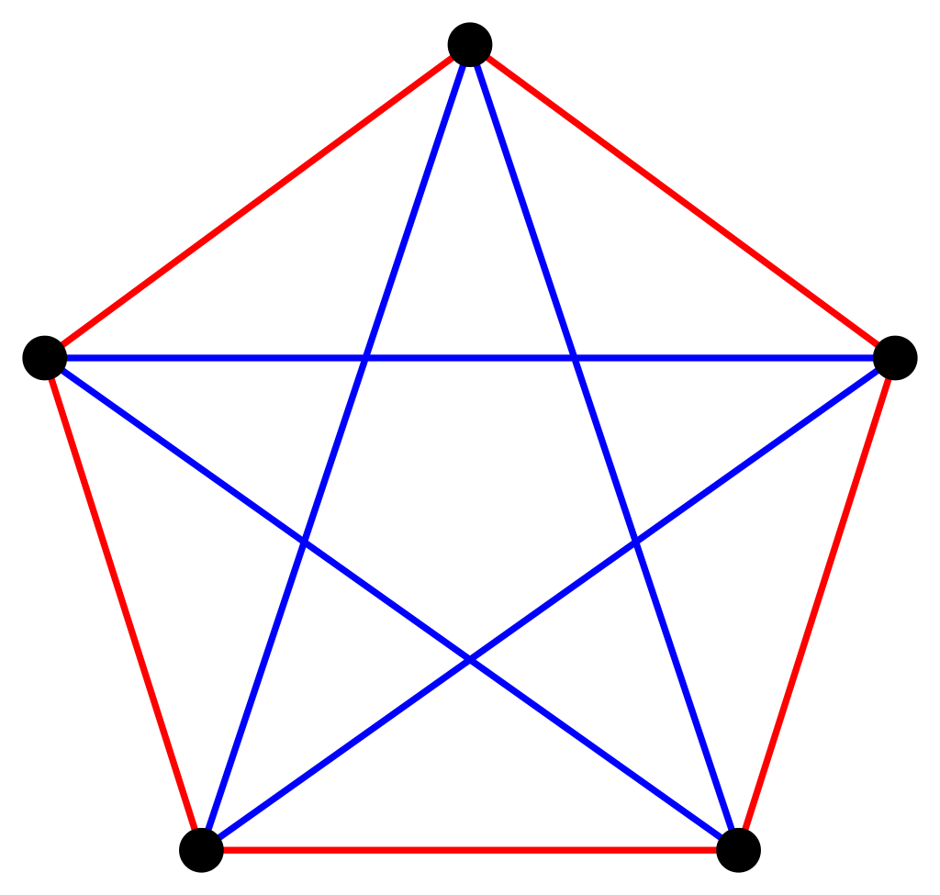A 2-edge-labeling of *K*5 with no monochromatic *K*3

**Examples****: *R*(3, 3) = 6:**

“Suppose the edges of a complete graph on 6 vertices are coloured red and blue. Pick a vertex, *v*. There are 5 edges incident to *v* and so (by the [pigeonhole principle](https://en.wikipedia.org/wiki/Pigeonhole_principle)) at least 3 of them must be the same colour. [Without loss of generality](https://en.wikipedia.org/wiki/Without_loss_of_generality) we can assume at least 3 of these edges, connecting the vertex, *v*, to vertices, *r*, *s* and *t*, are blue. (If not, exchange red and blue in what follows.) If any of the edges, (*r*, *s*), (*r*, *t*), (*s*, *t*), are also blue then we have an entirely blue triangle. If not, then those three edges are all red and we have an entirely red triangle. Since this argument works for any colouring, *any* *K*6 contains a monochromatic *K*3, and therefore *R*(3, 3) ≤ 6. The popular version of this is called the [theorem on friends and strangers](https://en.wikipedia.org/wiki/Theorem_on_friends_and_strangers).”

“An alternative proof works by [double counting](https://en.wikipedia.org/wiki/Double_counting_(proof_technique)). It goes as follows: Count the number of ordered triples of vertices, *x*, *y*, *z*, such that the edge, (*xy*), is red and the edge, (*yz*), is blue. Firstly, any given vertex will be the middle of either 0 × 5 = 0 (all edges from the vertex are the same colour), 1 × 4 = 4 (four are the same colour, one is the other colour), or 2 × 3 = 6 (three are the same colour, two are the other colour) such triples. Therefore, there are at most 6 × 6 = 36 such triples. Secondly, for any non-monochromatic triangle (**xyz**), there exist precisely two such triples. Therefore, there are at most 18 non-monochromatic triangles. Therefore, at least 2 of the 20 triangles in the *K*6 are monochromatic.”

“Conversely, it is possible to 2-colour a *K*5 without creating any monochromatic *K*3, showing that *R*(3, 3) > 5. The unique[[2]](https://en.wikipedia.org/wiki/Ramsey's_theorem" \l "cite_note-2) colouring is shown to the right. Thus *R*(3, 3) = 6.

The task of proving that *R*(3, 3) ≤ 6 was one of the problems of [William Lowell Putnam Mathematical Competition](https://en.wikipedia.org/wiki/William_Lowell_Putnam_Mathematical_Competition) in 1953, as well as in the Hungarian Math Olympiad in 1947.”

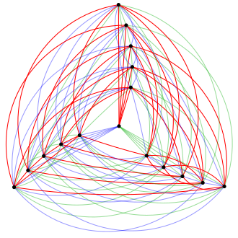

The only two 3-colourings of K16 with no monochromatic K3. The untwisted colouring (above) and the twisted colouring (below).

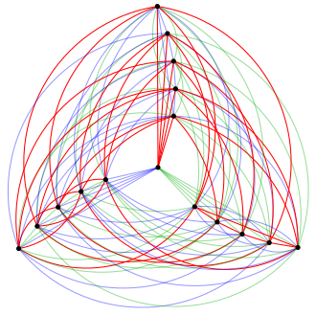

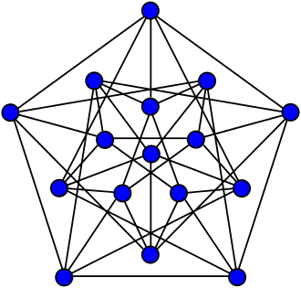

[Clebsch graph](https://en.wikipedia.org/wiki/Clebsch_graph)

## “Ramsey-numbers”:

“The numbers *R*(*r*, *s*) in Ramsey's theorem (and their extensions to more than two colours) are known as Ramsey numbers. The Ramsey number, *R*(*m*, *n*), gives the solution to the party problem, which asks the minimum number of guests, *R*(*m*, *n*), that must be invited so that at least *m* will know each other or at least *n* will not know each other. In the language of graph theory, the Ramsey number is the minimum number of vertices, *v* = *R*(*m*, *n*), such that all undirected simple graphs of order *v*, contain a clique of order *m*, or an independent set of order *n*. Ramsey's theorem states that such a number exists for all *m* and *n*.”

“By symmetry, it is true that *R*(*m*, *n*) = *R*(*n*, *m*). An upper bound for *R*(*r*, *s*) can be extracted from the proof of the theorem, and other arguments give lower bounds. (The first exponential lower bound was obtained by [Paul Erdős](https://en.wikipedia.org/wiki/Paul_Erdős) using the [probabilistic method](https://en.wikipedia.org/wiki/Probabilistic_method).) However, there is a vast gap between the tightest lower bounds and the tightest upper bounds. There are also very few numbers *r* and *s* for which we know the exact value of *R*(*r*, *s*).”

“Computing a lower bound *L* for *R*(*r*, *s*) usually requires exhibiting a blue/red colouring of the graph *KL*−1 with no blue *Kr* subgraph and no red *Ks* subgraph. Such a counterexample is called a *Ramsey graph*. [Brendan McKay](https://en.wikipedia.org/wiki/Brendan_McKay) maintains a list of known Ramsey graphs.[[6]](https://en.wikipedia.org/wiki/Ramsey's_theorem" \l "cite_note-McKay-6) Upper bounds are often considerably more difficult to establish: one either has to check all possible colourings to confirm the absence of a counterexample, or to present a mathematical argument for its absence.”

### Computational complexity

"[Erdős](https://en.wikipedia.org/wiki/Paul_Erdős) asks us to imagine an alien force, vastly more powerful than us, landing on Earth and demanding the value of *R*(5, 5) or they will destroy our planet. In that case, he claims, we should marshal all our computers and all our mathematicians and attempt to find the value. But suppose, instead, that they ask for *R*(6, 6). In that case, he believes, we should attempt to destroy the aliens.”

— [*Joel Spencer*](https://en.wikipedia.org/wiki/Joel_Spencer)*[[7]](https://en.wikipedia.org/wiki/Ramsey's_theorem" \l "cite_note-7)*

“A sophisticated computer program does not need to look at all colourings individually in order to eliminate all of them; nevertheless it is a very difficult computational task that existing software can only manage on small sizes. Each complete graph *Kn* has 1/2*n*(*n* − 1) edges, so there would be a total of *cn*(*n* − 1)/2 graphs to search through (for *c* colours) if brute force is used.[[8]](https://en.wikipedia.org/wiki/Ramsey's_theorem" \l "cite_note-8) Therefore, the complexity for searching all possible graphs (via [brute force](https://en.wikipedia.org/wiki/Brute-force_search)) is [O](https://en.wikipedia.org/wiki/Big_O_notation)(*cn*2) for *c* colourings and at most *n* nodes.

The situation is unlikely to improve with the advent of [quantum computers](https://en.wikipedia.org/wiki/Quantum_Computer). The best known algorithm[[*citation needed*](https://en.wikipedia.org/wiki/Wikipedia:Citation_needed)] exhibits only a quadratic speedup (c.f. [Grover's algorithm](https://en.wikipedia.org/wiki/Grover's_algorithm)) relative to classical computers, so that the [computation time](https://en.wikipedia.org/wiki/Time_complexity) is still [exponential](https://en.wikipedia.org/wiki/Exponential_growth) in the number of nodes.[[9]](https://en.wikipedia.org/wiki/Ramsey's_theorem" \l "cite_note-9)”

.

### **Known values**

### 

R(3, 3) = 6 as previously mentioned. Ramsey for 4,2 and Ramsey for any s,2 is always equal to s for any s. It is extremely simple to prove: As a counterexample, let us take a graph with s1 nodes and the edges when all coloured red proves that Ramsey of s,2 is always equal to s. A s-node red subgraph exists in the colouring of all edges coloured red, and a 2-node blue subgraph exists in all other colourings of a graph on s nodes (that is, a pair of nodes connected with a blue edge.)

The values of Ramsey of 4,3 can be calculated using values of Ramsey for 4,2 and 3,3. Similarly, it is easy to deduce the values of Ramsey of 4,4 for 2-coloruing. Various colourings of graph were constructed to find lower bounds of these numbers, and finally Ramsey of 4,4 has been deduced to be 18.

The exact values of Ramsey of 5,5 is unknown, but it known to lie between 43 and 48. The exact value of Ramsey of 4,5 is however known to be exactly 25.

McKay, Radziszowski, and Exoo proposed R(5, 5) = 43 in 1997 using computer-assisted graph generation methods. They could construct exactly 656 graphs by taking various paths to the same set of graphs. There is no way to make a (5, 5, 43) graph out of any of the 656 graphs.

Only weak bounds are available for Ramsey of r,s with r and s greater than 5. Since 1965 and 1972, the lower limits for R(6, 6) and R(8, 8) have remained unchanged. [three]

In the table below, R(r, s) with r, s 10 is shown. The table lists the best known bounds when the exact value is unknown. Ramsey of 1,s being equal to 1 and Ramsey of 2,s is equal to s for all values of s.

The Dynamic Survey 1 of the Electronic Journal of Combinatorics, edited by Stanisaw Radziszowski and updated on a regular basis, is the standard survey on the growth of Ramsey number science. [three] The entries that are there in the table below are from the the edition of 2017 March unless otherwise noted. (Note that R(r, s) = R(s, r) has a trivial symmetry around the diagonal.)

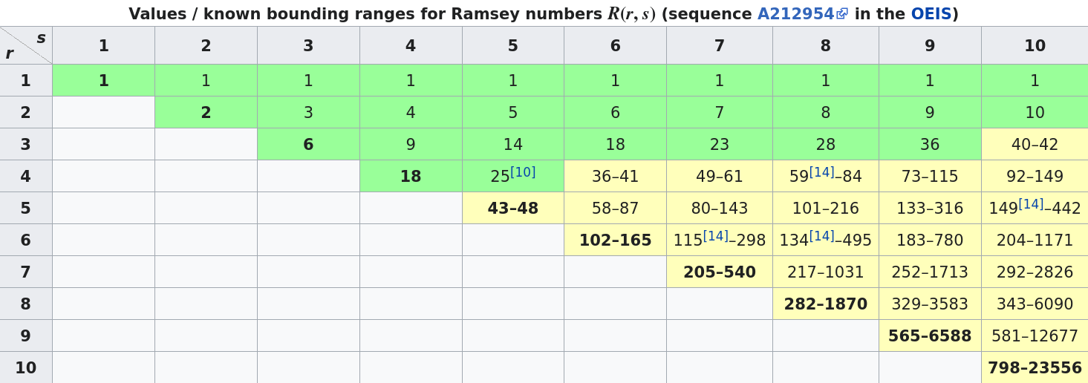

**Social Media Analytics and Ramsey Theorem**

The requirement for this research project is to build two-coloured graphs using social media networks . Each node in the graph will represent a person/user of the social media, connected to another node using either of the two colours, e.g. blue and red, one colour representing both of them are connected to each other using the social media, and the other colour representing the two of them not being connected to each other via the social media. Our aim is to find, through statistical experiments, the minimum and maximum number of nodes needed, i.e, the interval with highest probability to find monochromatic cliques each of edges 6,7,8 etc respectively.

**Motivation and Problem Statement**

In our research analysis project, we will survey on social media graphs taken from Facebook users of MIT and see how much the results are close to the Ramsey Theorem in practice.

That is, Ramsey’s theorem gives a minimum number of edges to guarantee the existence of a monochromatic clique of either red color or blue color.

In our experiment, we have designed red colored edge as knowing each other in Facebook, and blue colored edge as not-knowing each other in Facebook, where the complete graph is formed by vertices where each vertex is an user of Facebook.

We will see by this research survey how many people actually form a blue clique, that is, know each other, versus how many people actually form a red-clique, that is, do not know each other.

In this way, we can have a practical understanding on how many people usually know each other versus how many people usually do-not know each other in a random party thrown at MIT consisting of N number of people (in our experiment, N will be 6 and 18, as we will see). Thus, this is a research analysis of the famous Party Problem as in practice with real-world social media analytics.

Innovation in our project:

1) Use of Social Media Analytics to determine Combinatorial Graph Theoretic results

2) Use of the software Mathematica to build large graphs not explored much before

3) Surveying the Party Problem in practice with real-world social media datas

4) Can open up a broad spectrum of research in the future

**CHAPTER 2**

**LITERATURE SURVEY**

1. **BACKGROUND STUDY:**

Radziszowski's Dynamic Survey in the Electronic Journal of Combinatorics was recommended for a survey of the most recent findings on Ramsey graphs. The combinatorial data page of Ramsey Graphs was widely used for details on the data format used.

1. **SUMMARY OF LITERATURE REVIEW:**
2. “[Small Ramsey Numbers](https://www.combinatorics.org/ojs/index.php/eljc/article/view/DS1)

Stanisław Radziszowski

DS1: Jan 15, 2021

2011-08-22 ”

“In this paper, the author presents data which, to the best of our knowledge, includes all known nontrivial values and bounds for specific graph, hypergraph and multicolor Ramsey numbers, where the avoided graphs are complete or complete without one edge. Many results pertaining to other more studied cases are also presented. They give references to all cited bounds and values, as well as to previous similar compilations. They do not attempt complete coverage of asymptotic behavior of Ramsey numbers, but concentrate on their specific values.”

1. “[Ramsey Theory Applications](https://www.combinatorics.org/ojs/index.php/eljc/article/view/DS13)

Vera Rosta

DS13: Dec 7, 2004

2004-12-07 ”

“There are many interesting applications of Ramsey theory, these include results in number theory, algebra, geometry, topology, set theory, logic, ergodic theory, information theory and theoretical computer science. Relations of Ramsey-type theorems to various fields in mathematics are well documented in published books and monographs. The main objective of this survey is to list applications mostly in theoretical computer science of the last two decades not contained in these.”

[3] “[Ramsey Numbers of Ordered Graphs](https://www.combinatorics.org/ojs/index.php/eljc/article/view/v27i1p16)

Martin Balko, Josef Cibulka, Karel Král, Jan Kynčl

P1.16

2020-01-10 ”

“For a few special classes of ordered paths, stars or matchings, they give asymptotically tight bounds on their ordered Ramsey numbers. For so-called monotone cycles they compute their ordered Ramsey numbers exactly. This result implies exact formulas for geometric Ramsey numbers of cycles introduced by Károlyi, Pach, Tóth, and Valtr.”

[4] “[Constructive Lower Bounds on Classical Multicolor Ramsey Numbers](https://www.combinatorics.org/ojs/index.php/eljc/article/view/v11i1r35)

“Xu Xiaodong, Xie Zheng, Geoffrey Exoo, Stanisław P. Radziszowski

R35

2004-06-04 ”

This paper looks at lower bounds for classical multicolor Ramsey numbers, first providing a brief summary of previous work and then introducing several general constructions that define new lower bounds for a variety of diagonal and off-diagonal multicolor Ramsey numbers.

The majority of the new lower limits are the product of broad constructions.” ”

[5] “[The Ramsey Number of Loose Paths in 3-Uniform Hypergraphs](https://www.combinatorics.org/ojs/index.php/eljc/article/view/v20i1p12)

Leila Maherani, Gholam Reza Omidi, Ghaffar Raeisi, Maryam Shahsiah

P12

2013-01-21 ”

“Recently, asymptotic values of 2-color Ramsey numbers for loose cycles and also loose paths were determined. Here they determine the 2-color Ramsey number of 3-uniform loose paths when one of the paths is significantly larger than the other.”

**CHAPTER 3**

**SYSTEM ANALYSIS**

A social friendship network extracted from Facebook consisting of people (nodes) with edges representing friendship ties was used from MIT was used in our research analysis.

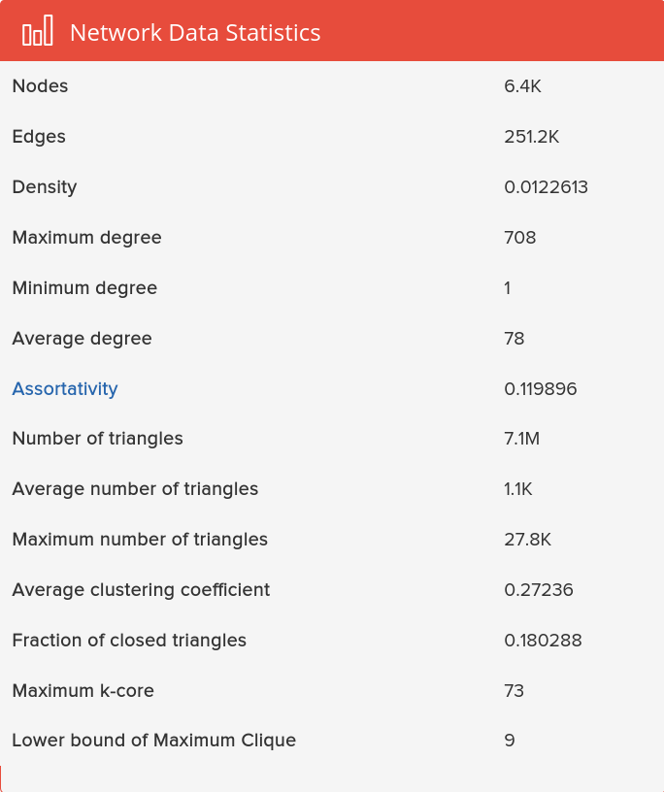

**Fig 3.1: Network Data Statistics**

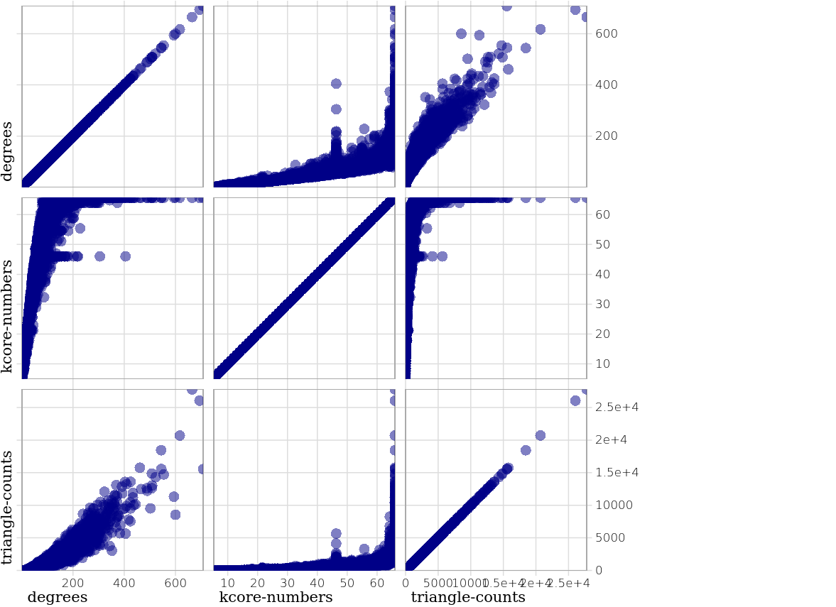

**Fig 3.2: Node-level Statistics**

#### Node-level Feature Distributions

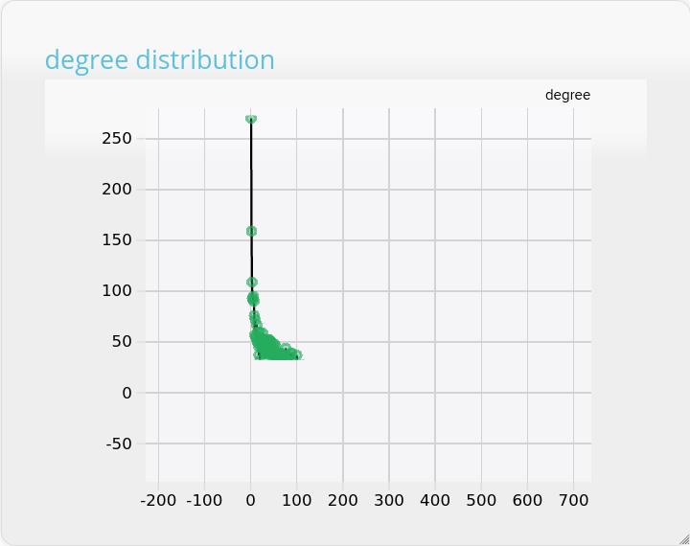

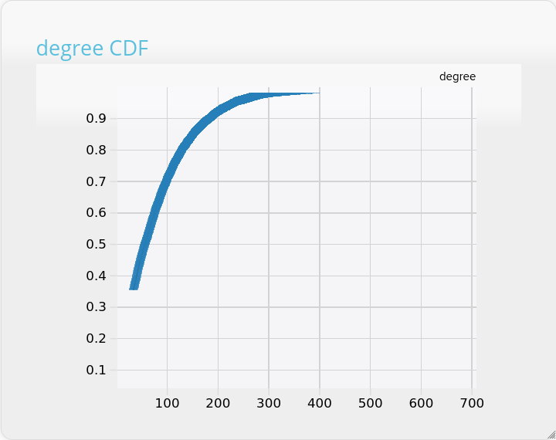

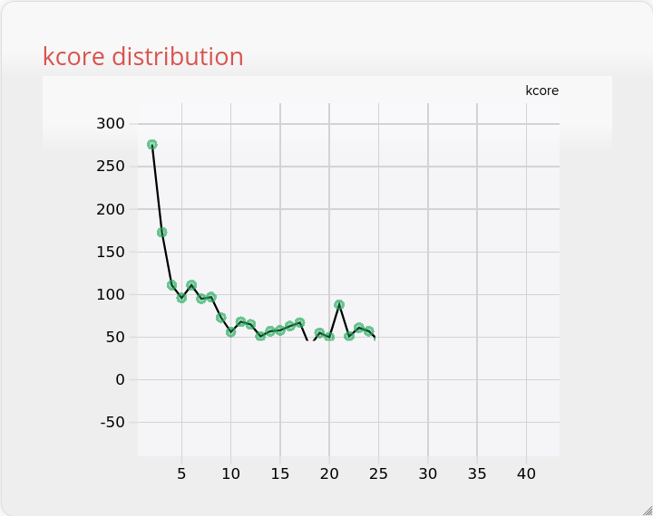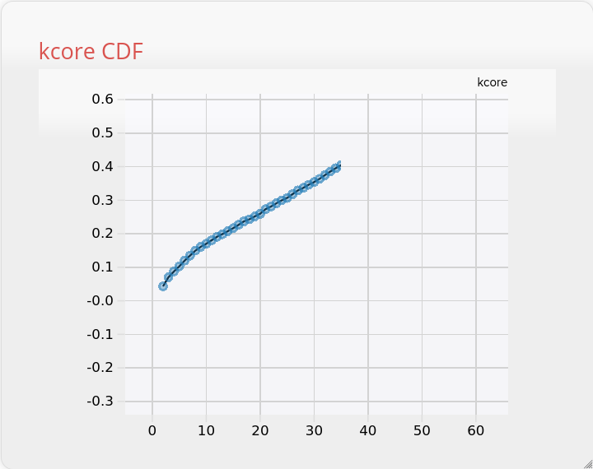

·

**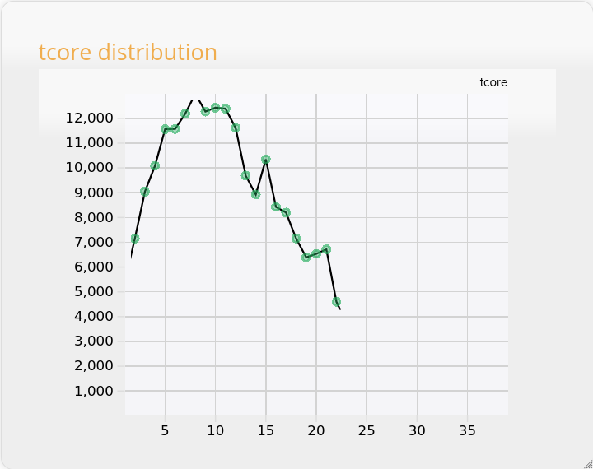**

**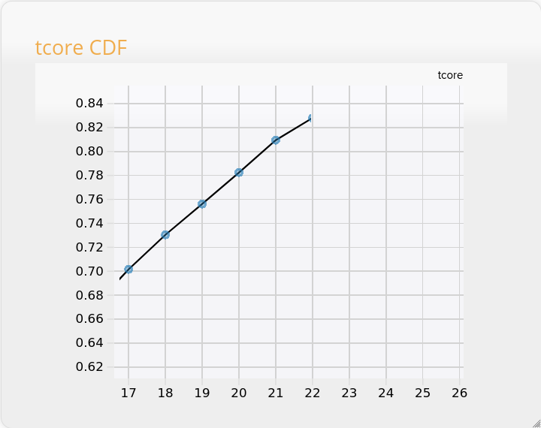**

**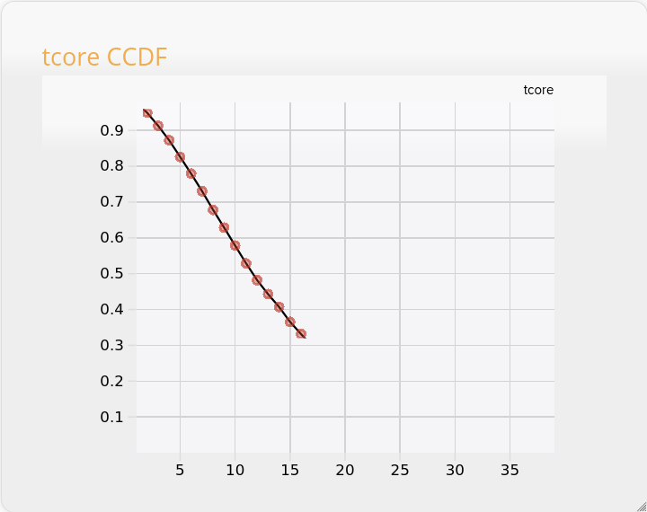**

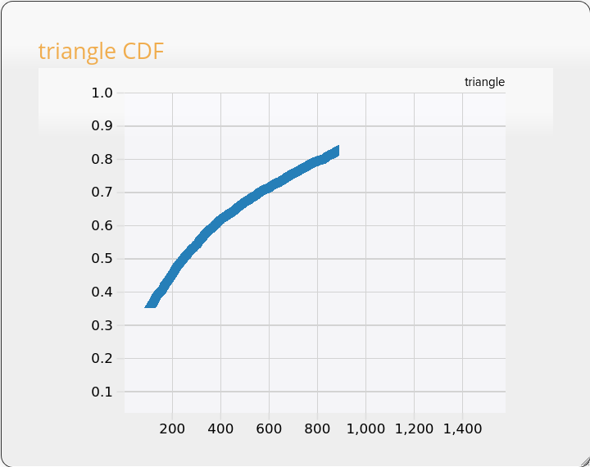

**CHAPTER 4**

**SYSTEM DESIGN & ARCHITECTURE**

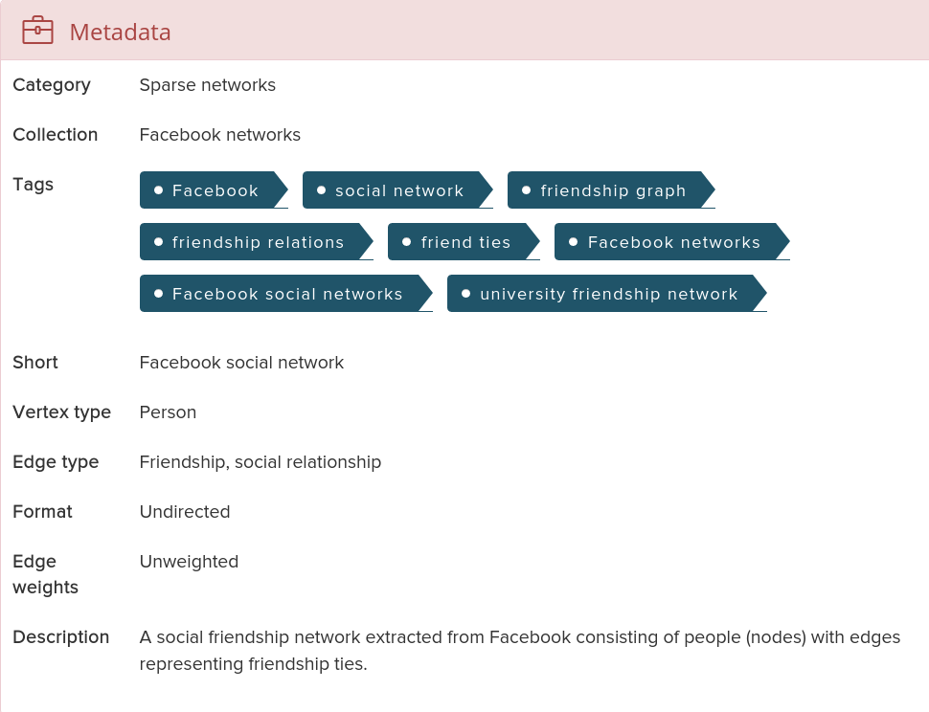

**Fig 4.1 Metadata of the social network graph used from MIT**

1. **WORKING PRINCIPLE**

A complete graph consisting of undirected edges were created using MIT Facebook Analytics.

As stated above, the data had 6.4K nodes, where a connected to b meant that node a was connected to node b in Facebook. These edges were coloured red. The nodes that did not know each other were also joined using blue edges to make it a complete graph.

The above manipulation was done using the software Mathematica licensed under Wolfram Research, Inc, a very good tool to do these mathematical manipulations of graphs, etc.

1. **COMPONENTS OF PROJECT**

**The**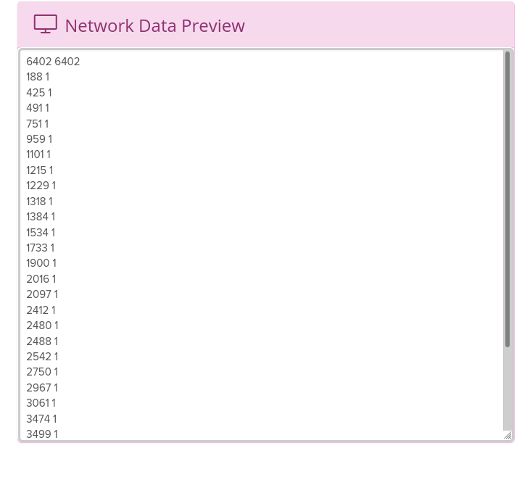 **Graph Edges**

**Importing the data in Mathematica and converting it to expression from strings:**

**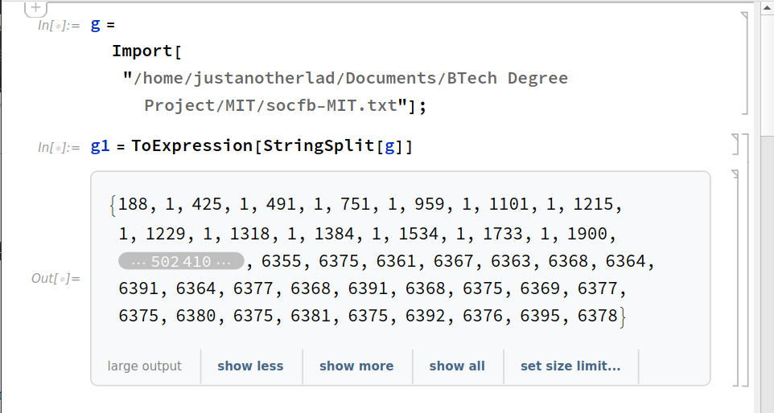**

**Forming a complete graph with every vertex connected to each other, the number of vertices being same as that in the imported data:**

**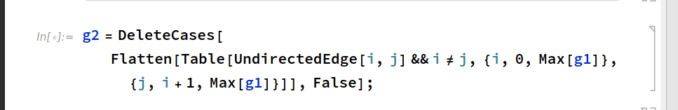**

**Edge manipulation:**

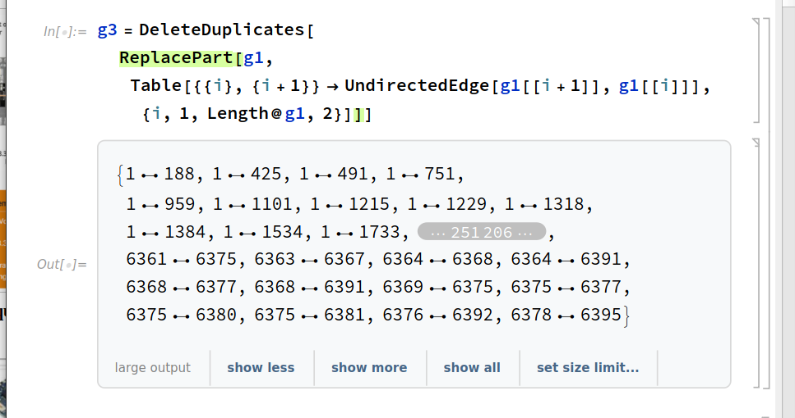

**Manipulating the graph such that the edges representing people connected in Facebook becomes Red, and the edges representing people not connected in Facebook becomes white:**

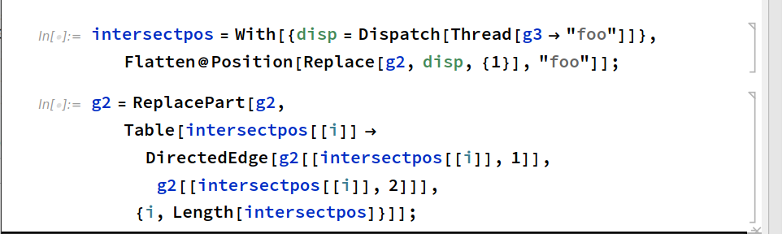

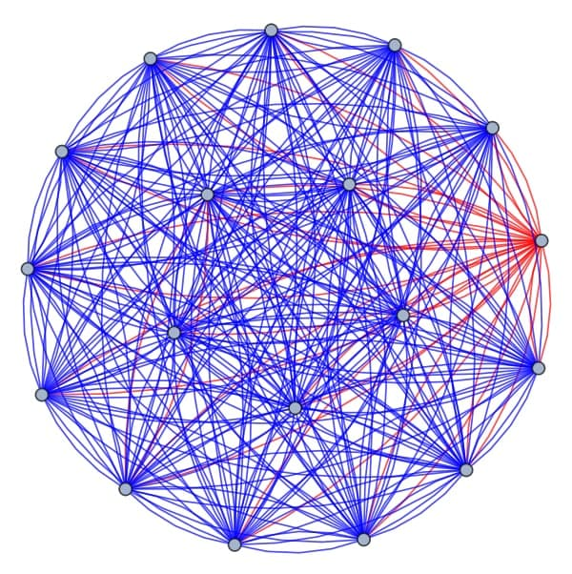

**Fig: An example graph where each node represents an user and two nodes connected by blue edge represents they are not connected in Facebook, and two nodes connected via red edge means they are connected in Facebook as per the imported graph data of MIT.**

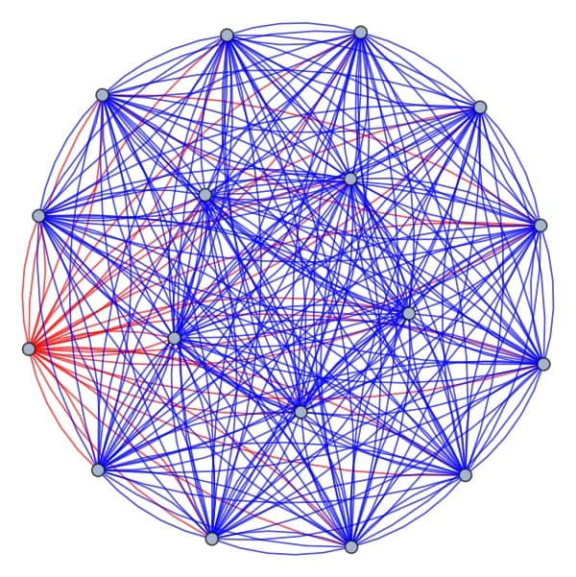

**Fig: Another example graph**

**Final function construction to check monochromatic cliques:**

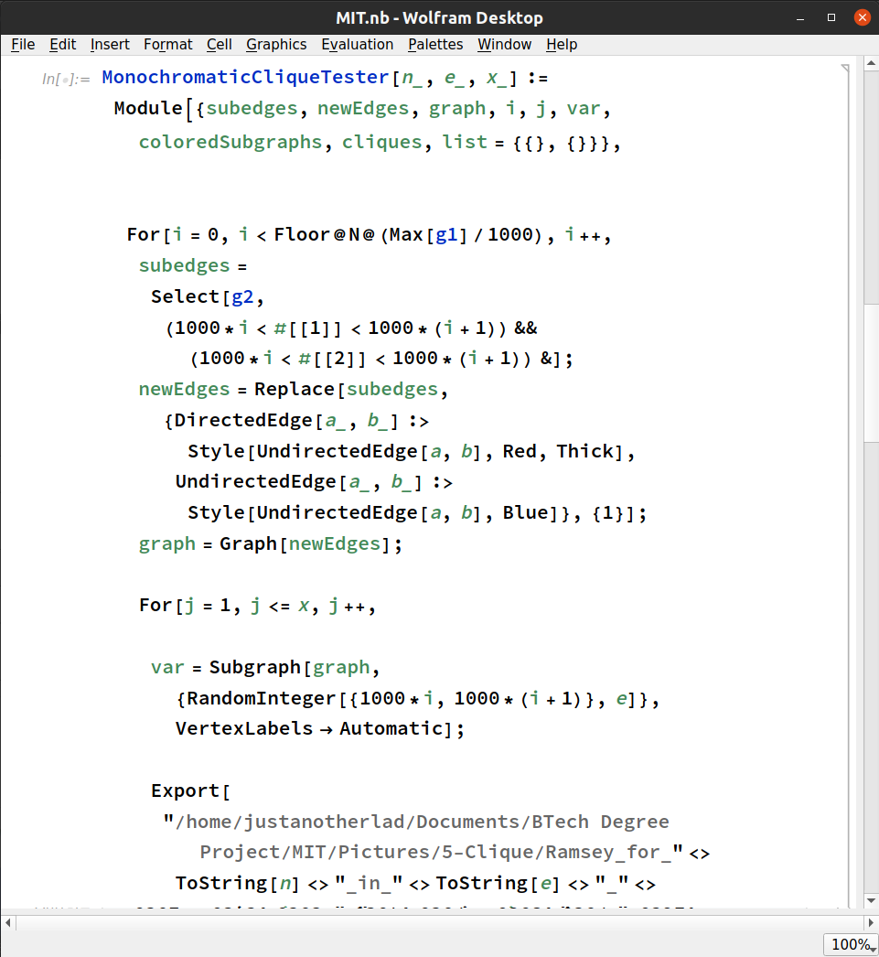

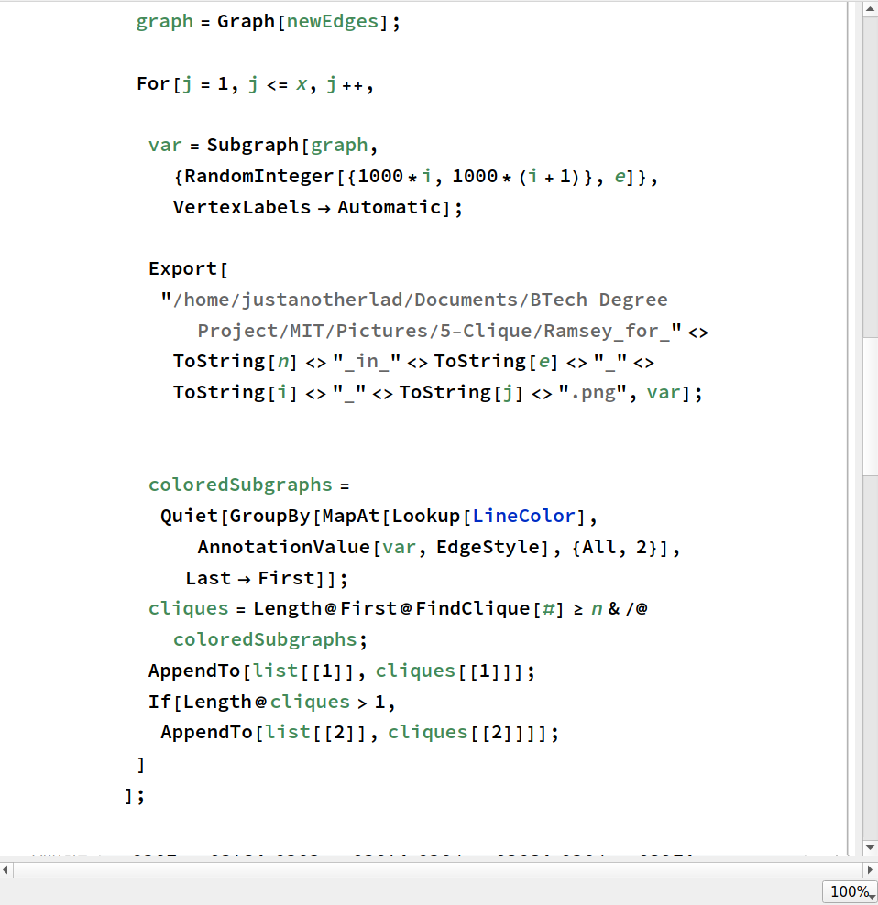

**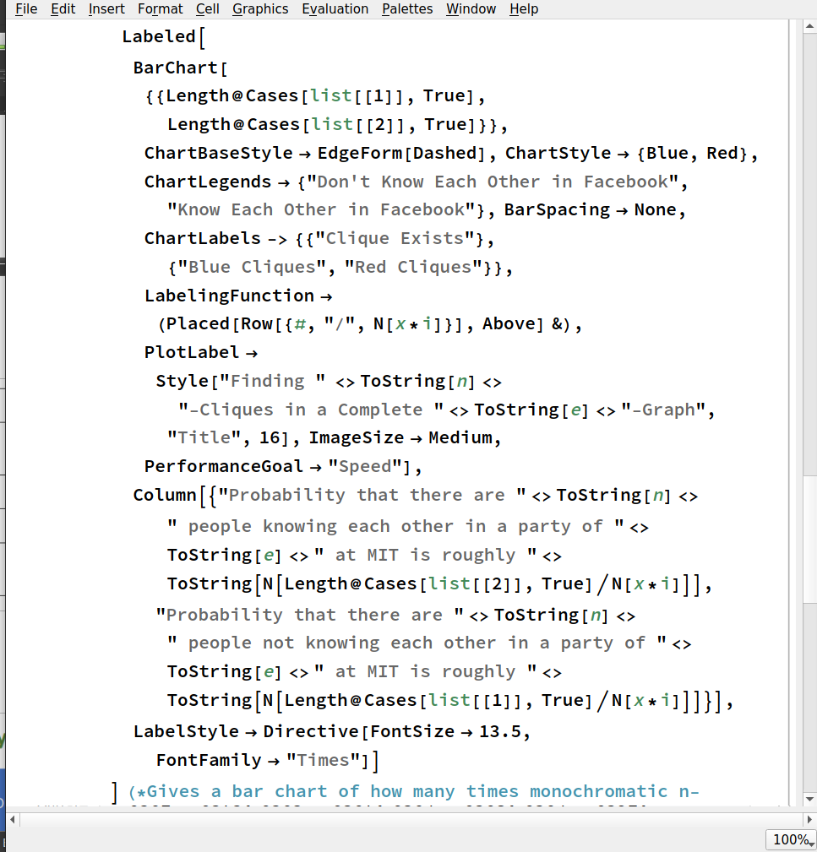**

**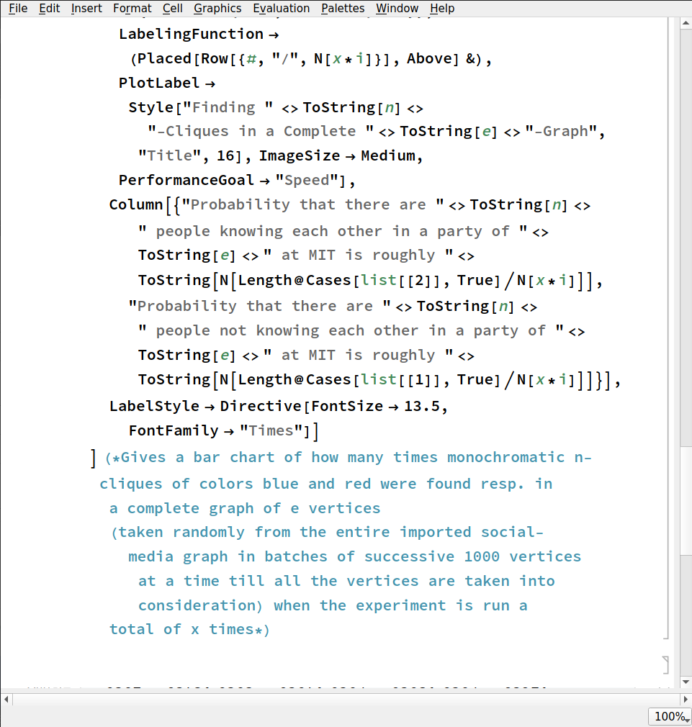**

**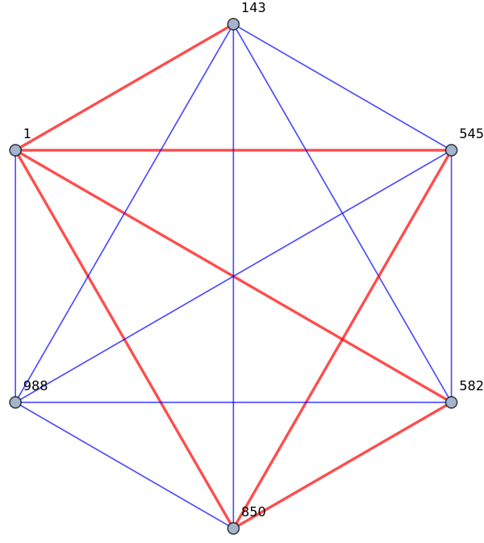**

**Fig: A final example of the type of clique the MonochromaticCliqueTester[ ] function can find. Here node 1, 545 and 850 form a 3-clique in this complete 6-graph, hence proving Ramsey’s theorem that in any random complete graph of 6 vertices, there always exist a 3-clique of either red color or blue colour (in case of 2-coloring).**

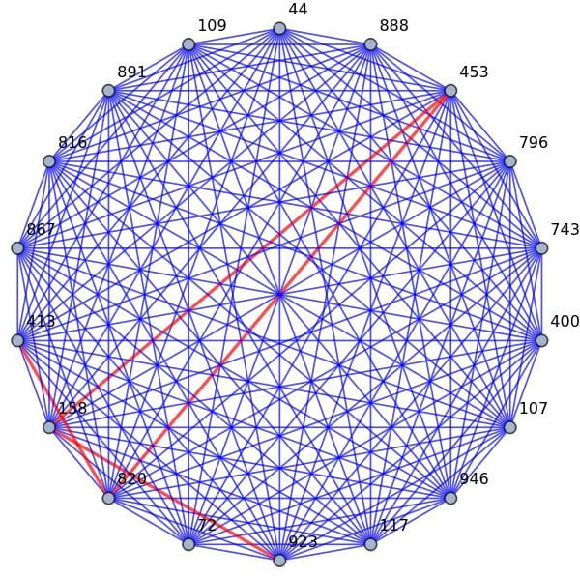

**Fig: Another example of attempt to find monochromatic cliques in a larger complete graph of 18 people.**

**CHAPTER 5**

**SYSTEM TESTING**

**1.General**

Testing is performed in order to ensure that our project is giving the desired outcome or not, it is also helpful in giving the value of efficiency and accuracy of the project. Testing at multiple stages is performed in order to ensure that our project is giving desired outcomes at each and every level. Even if one module of our project fails then our system as a whole fails and hence, testing at every level is very important because that's the only way of ensuring the working of the project is fine and we can carry on further with our project. Therefore, testing is a non compromisable part of our project. In simple terms, it is performed to do 2 things

i.) to ensure whether we are getting the same result as expected.

ii.) whether or not our system has any bugs.

Hence, we should take testing very seriously.

Our experiment was tested on the imported MIT graph network data of 6.4K vertices, where each vertex represented an user in Facebook. An edge connected in Red represented whether they knew each other on Facebook, and an edge in Blue represented that they did not know each other on Facebook.  
  
Our aim was to find, in a random party at MIT consisting of 6 or 18 people, what is the probability that 6 people or 18 people (respectively) will know each other or not know each other, based on this trusted imported graph network.

Our experiment was run 100 times each for every successive batch of 1000 vertices, i.e, a total of 600 times each to determine the 3-clique probability for 6-graph and 4-clique probability in 18-graph respectively.

We provide the images of the graphs so formed in our experiment as follows:

**3-Cliques in a complete 6-graph, where Red edges represent the nodes know each other in Facebook, and Blue edges represent they do not know each other.**

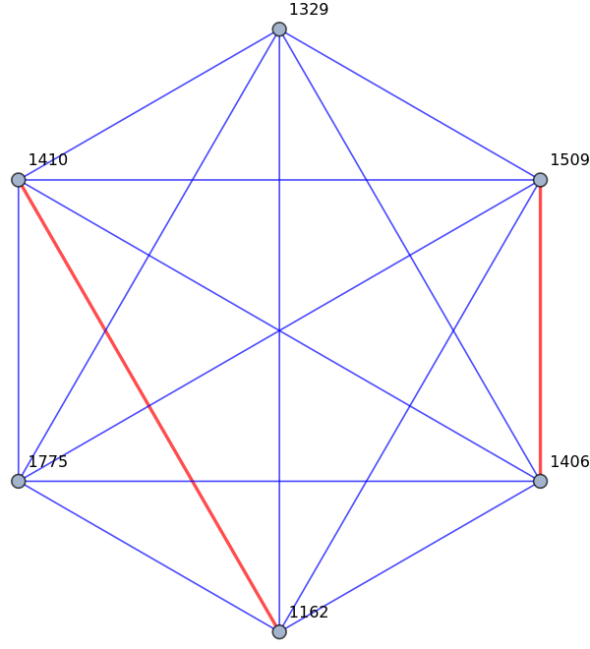

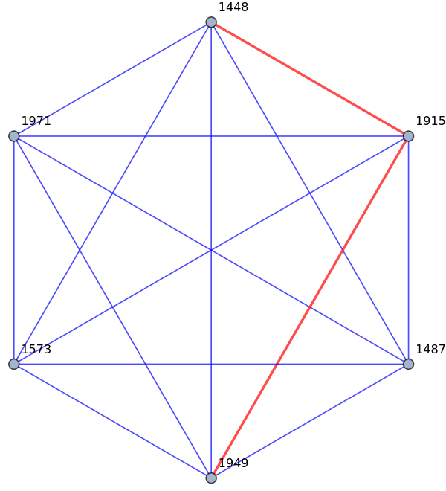

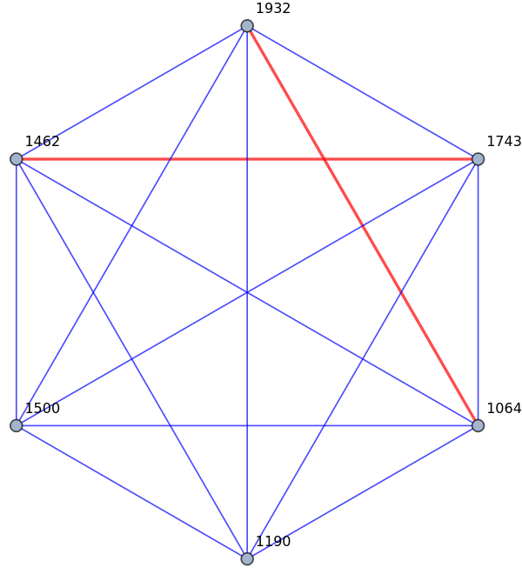

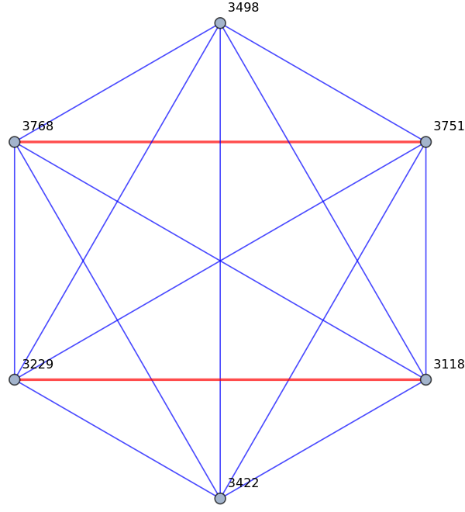

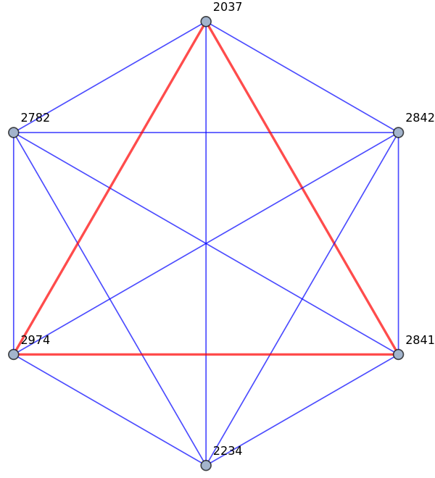

**Fig: A Red 3-Clique was found, representing there are 3 people knowing each other, as predicted by Ramsey**

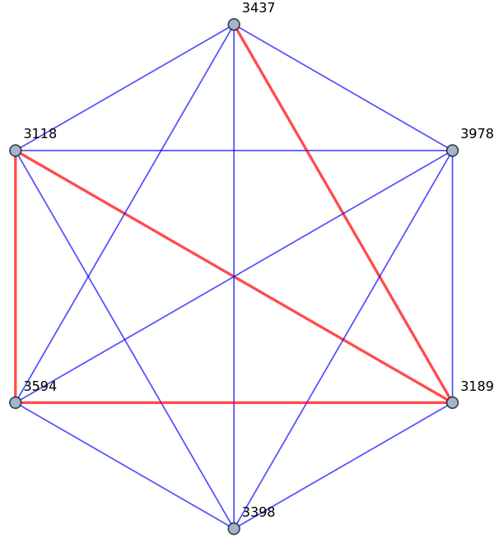

**Fig: Another similar graph was found**

### 

**4-Cliques in a complete 18-graph, where Red edges represent the nodes know each other in Facebook, and Blue edges represent they do not know each other.**

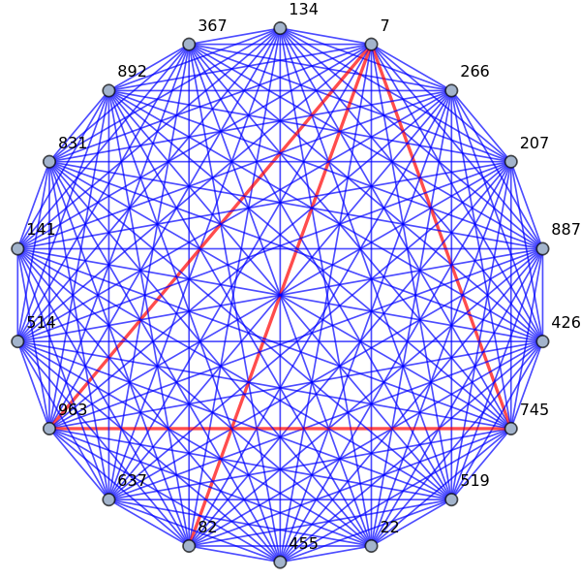

**Fig: A 3-Clique found in an 18-graph**

**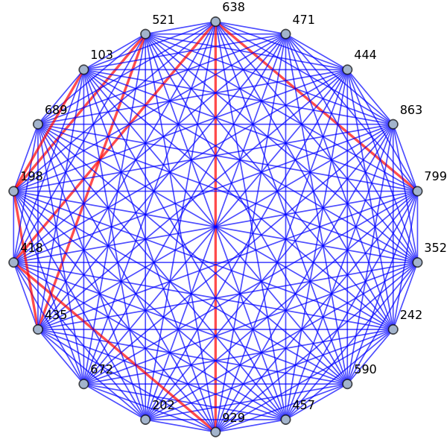**

**Fig: A much more complex example.**

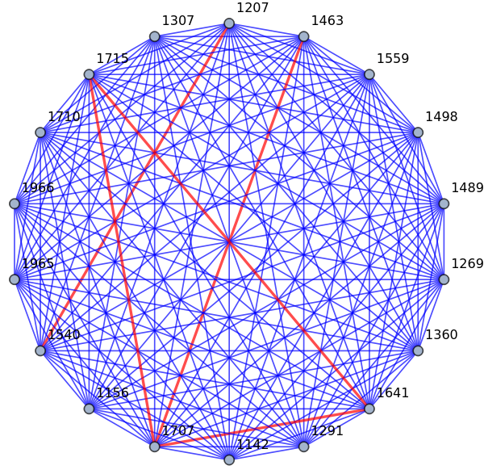

**Fig: Another 3-Clique found. However, note, this is not a 4-Clique still that we are searching for in this 18-graph.**

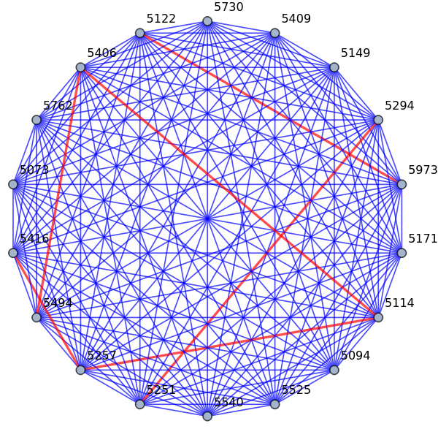

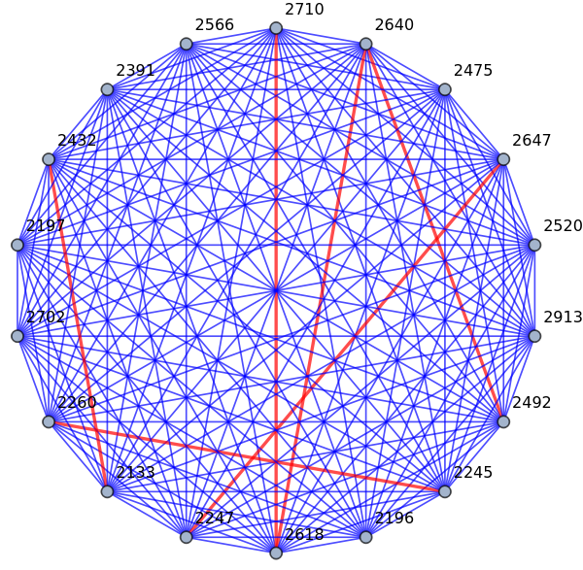

**Fig: Another complex graph with vertices 2710 and 2618 knowing each other, etc.**

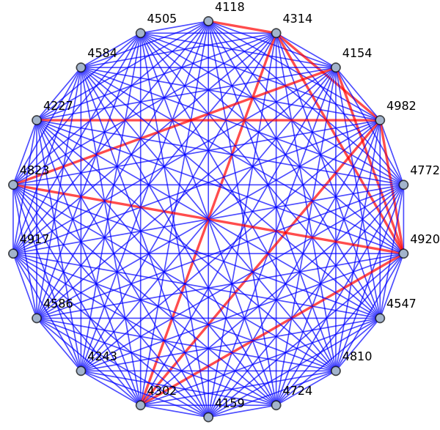

**Fig: Yet another example where node 4154, 4828 and 4920 forms a 3-clique, and node s 4982, 4920 and 4302 also forms a 3-clique**

**CHAPTER 6**

**RESULT AND ANALYSIS**

**The expected results for this project are:**

i. Ito determine the probability of 3 people and 4 people knowing each other versus not knowing each other in a random party thrown at MIT consisting of 6 people and 18 people respectively.

ii. Analyze Ramsey Theorem using existing Social Media Analytics

iii. Have a practical understanding of the famous party problem, how likely it is for people to not-know each other compared to know each other based on the data used.

**RESULT:** In this project I found out that people not-knowing each other inside a college like MIT is far more than people knowing each other, when they are in a random party of 6 people or 18 people. The conclusing was drawn from Social Media Analytics and graph manipulation and concepts of Ramsey Theorem.

.

**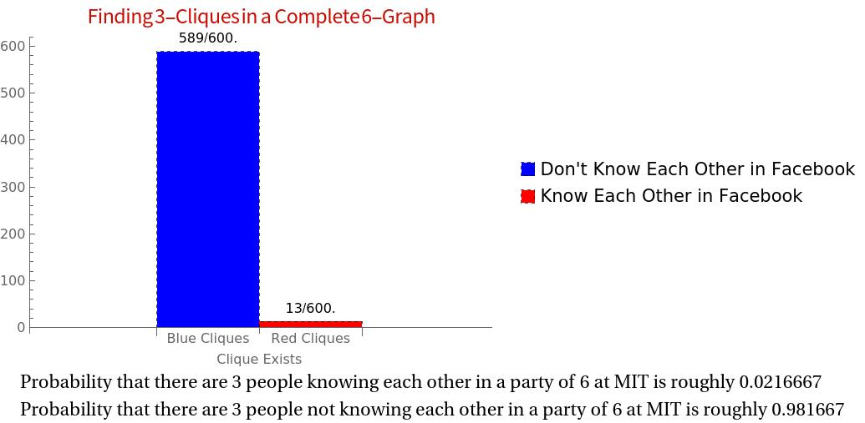**

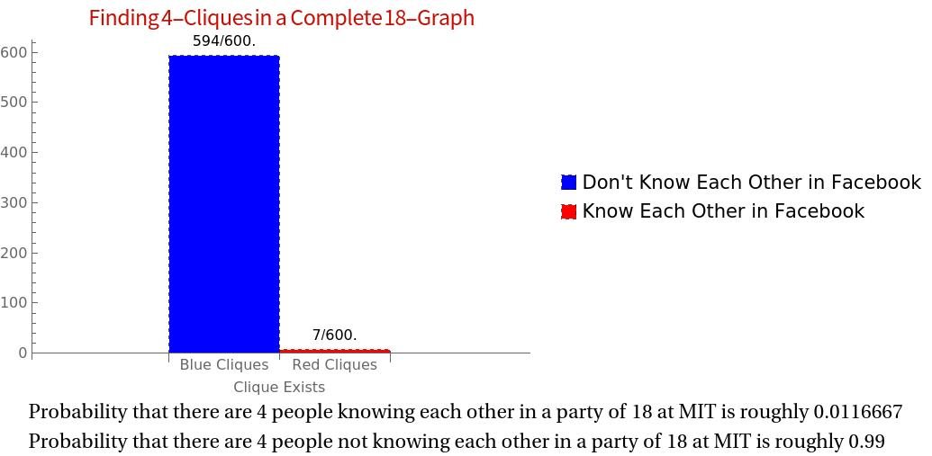

**Difficulties Faced**

1. The main problem that was faced during this project was the limited performance of the software and computer hardware used.

In the absence of GPUs, most graph computations can be a cumbersome task.  
I used my personal computer with a processor of Intel Core i5 for this experiment, which sometimes resulted in lag in obtaining results.

2. Apart from that, another major difficulty was the big size of data. Often dealing with huge datas can be difficult for manipulation unless using a distributed system.

3. The last issue faced in this research was the dependency of the result on data used. The final outcome is entirely dependant on the particular data I am using, and it no way guarantees that the outcome will be any way close to this outcome if any other data is used.

**Analysis of project**

Table 6.1 : Analysis of the probability values of Knowing Each Other and Not-Knowing Each Other using MIT data.

|  |  |  |  |
| --- | --- | --- | --- |
| **Sr. No.** | **Number of People at Party** | **Category of Determination** | **while sensor sense** |
| 1 | 6 | **Any random 3 people Knowing Each Other:**  **3 people Not Knowing Each Other:** | **0.0216667**  **0.981667** |
| 2 | 18 | **Any random 4 People Knowing Each Other:**  **4 People Not Knowing Each Other:** | **0.0116667**  **0.99** |

**CHAPTER 7**

**CONCLUSION AND FUTURE SCOPE**

**7.1 CONCLUSION**

Our experiment determines that practically, in the famous party problem, the probability of people not knowing each other is far more than people knowing each other, althought theoretically we assume both are equally likely.

**7.2 FUTURE SCOPE**

1. This experiment can be used to determine lower bounds for larger Ramsey Numbers
2. Similar Social Media Analysis can be done to obtain results in the fields of Combinatorics or Graph Theory.

**REFERENCES**

“

* Bohman, Tom; Keevash, Peter (2010), "The early evolution of the H-free process", Invent. Math., **181** (2): 291–336, [*arXiv*](https://en.wikipedia.org/wiki/ArXiv_(identifier)):[*0908.0429*](https://arxiv.org/abs/0908.0429), [*Bibcode*](https://en.wikipedia.org/wiki/Bibcode_(identifier)):[*2010InMat.181..291B*](https://ui.adsabs.harvard.edu/abs/2010InMat.181..291B), [*doi*](https://en.wikipedia.org/wiki/Doi_(identifier)):[*10.1007/s00222-010-0247-x*](https://doi.org/10.1007%2Fs00222-010-0247-x)
* Brualdi, Richard A. (2010), Introductory Combinatorics (5th ed.), Prentice-Hall, pp. 77–82, [*ISBN*](https://en.wikipedia.org/wiki/ISBN_(identifier))
* Conlon, David (2009), "A new upper bound for diagonal Ramsey numbers", [*Annals of Mathematics*](https://en.wikipedia.org/wiki/Annals_of_Mathematics), **170** (2): 941–960, [*arXiv*](https://en.wikipedia.org/wiki/ArXiv_(identifier)):[*math/0607788v1*](https://arxiv.org/abs/math/0607788v1), [*doi*](https://en.wikipedia.org/wiki/Doi_(identifier)):[*10.4007/annals.2009.170.941*](https://doi.org/10.4007%2Fannals.2009.170.941), [*MR*](https://en.wikipedia.org/wiki/MR_(identifier)) [*2552114*](https://www.ams.org/mathscinet-getitem?mr=2552114).
* [*Erdős, Paul*](https://en.wikipedia.org/wiki/Paul_Erdős) (1947), "Some remarks on the theory of graphs", Bull. Amer. Math. Soc., **53** (4): 292–294, [*doi*](https://en.wikipedia.org/wiki/Doi_(identifier)):[*10.1090/S0002-9904-1947-08785-1*](https://doi.org/10.1090%2FS0002-9904-1947-08785-1).
* [*Erdős, P.*](https://en.wikipedia.org/wiki/Paul_Erdős); Moser, L. (1964), [*"On the representation of directed graphs as unions of orderings"*](https://users.renyi.hu/~p_erdos/1964-22.pdf) (PDF), A Magyar Tudományos Akadémia, Matematikai Kutató Intézetének Közleményei, **9**: 125–132, [*MR*](https://en.wikipedia.org/wiki/MR_(identifier)) [*0168494*](https://www.ams.org/mathscinet-getitem?mr=0168494)
* [*Erdős, Paul*](https://en.wikipedia.org/wiki/Paul_Erdős); [*Szekeres, George*](https://en.wikipedia.org/wiki/George_Szekeres) (1935), [*"A combinatorial problem in geometry"*](http://www.numdam.org/article/CM_1935__2__463_0.pdf) (PDF), [*Compositio Mathematica*](https://en.wikipedia.org/wiki/Compositio_Mathematica), **2**: 463–470, [*doi*](https://en.wikipedia.org/wiki/Doi_(identifier)):[*10.1007/978-0-8176-4842-8\_3*](https://doi.org/10.1007%2F978-0-8176-4842-8_3), [*ISBN*](https://en.wikipedia.org/wiki/ISBN_(identifier)) .
* Exoo, G. (1989), "A lower bound for R(5,5)", Journal of Graph Theory, **13**: 97–98, [*doi*](https://en.wikipedia.org/wiki/Doi_(identifier)):[*10.1002/jgt.3190130113*](https://doi.org/10.1002%2Fjgt.3190130113).
* [*Graham, R.*](https://en.wikipedia.org/wiki/Ronald_Graham); Rothschild, B.; [*Spencer, J. H.*](https://en.wikipedia.org/wiki/Joel_Spencer) (1990), Ramsey Theory, New York: John Wiley and Sons.
* Gross, Jonathan L. (2008), Combinatorial Methods with Computer Applications, CRC Press, p. 458, [*ISBN*](https://en.wikipedia.org/wiki/ISBN_(identifier))
* Harary, Frank (1972), Graph Theory, Addison-Wesley, pp. 16–17, [*ISBN*](https://en.wikipedia.org/wiki/ISBN_(identifier))
* [*Ramsey, F. P.*](https://en.wikipedia.org/wiki/Frank_P._Ramsey) (1930), "On a problem of formal logic", Proceedings of the London Mathematical Society, **30**: 264–286, [*doi*](https://en.wikipedia.org/wiki/Doi_(identifier)):[*10.1112/plms/s2-30.1.264*](https://doi.org/10.1112%2Fplms%2Fs2-30.1.264).
* [*Spencer, J.*](https://en.wikipedia.org/wiki/Joel_H._Spencer) (1975), "Ramsey's theorem – a new lower bound", J. Combin. Theory Ser. A, **18**: 108–115, [*doi*](https://en.wikipedia.org/wiki/Doi_(identifier)):[*10.1016/0097-3165(75)90071-0*](https://doi.org/10.1016%2F0097-3165(75)90071-0).
* Bian, Zhengbing; Chudak, Fabian; Macready, William G.; Clark, Lane; Gaitan, Frank (2013), "Experimental determination of Ramsey numbers", Physical Review Letters, **111** (13): 130505, [*arXiv*](https://en.wikipedia.org/wiki/ArXiv_(identifier)):[*1201.1842*](https://arxiv.org/abs/1201.1842), [*Bibcode*](https://en.wikipedia.org/wiki/Bibcode_(identifier)):[*2013PhRvL.111m0505B*](https://ui.adsabs.harvard.edu/abs/2013PhRvL.111m0505B), [*doi*](https://en.wikipedia.org/wiki/Doi_(identifier)):[*10.1103/PhysRevLett.111.130505*](https://doi.org/10.1103%2FPhysRevLett.111.130505), [*PMID*](https://en.wikipedia.org/wiki/PMID_(identifier)) [*24116761*](https://pubmed.ncbi.nlm.nih.gov/24116761).

“

**APPENDIX**

1. **PROGRAMMING**

**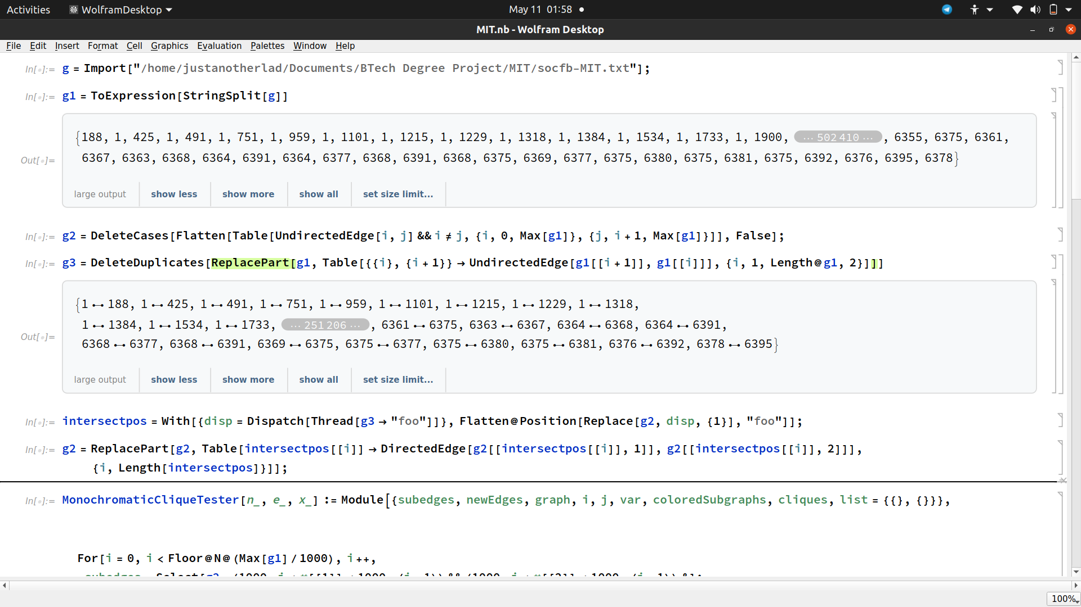**

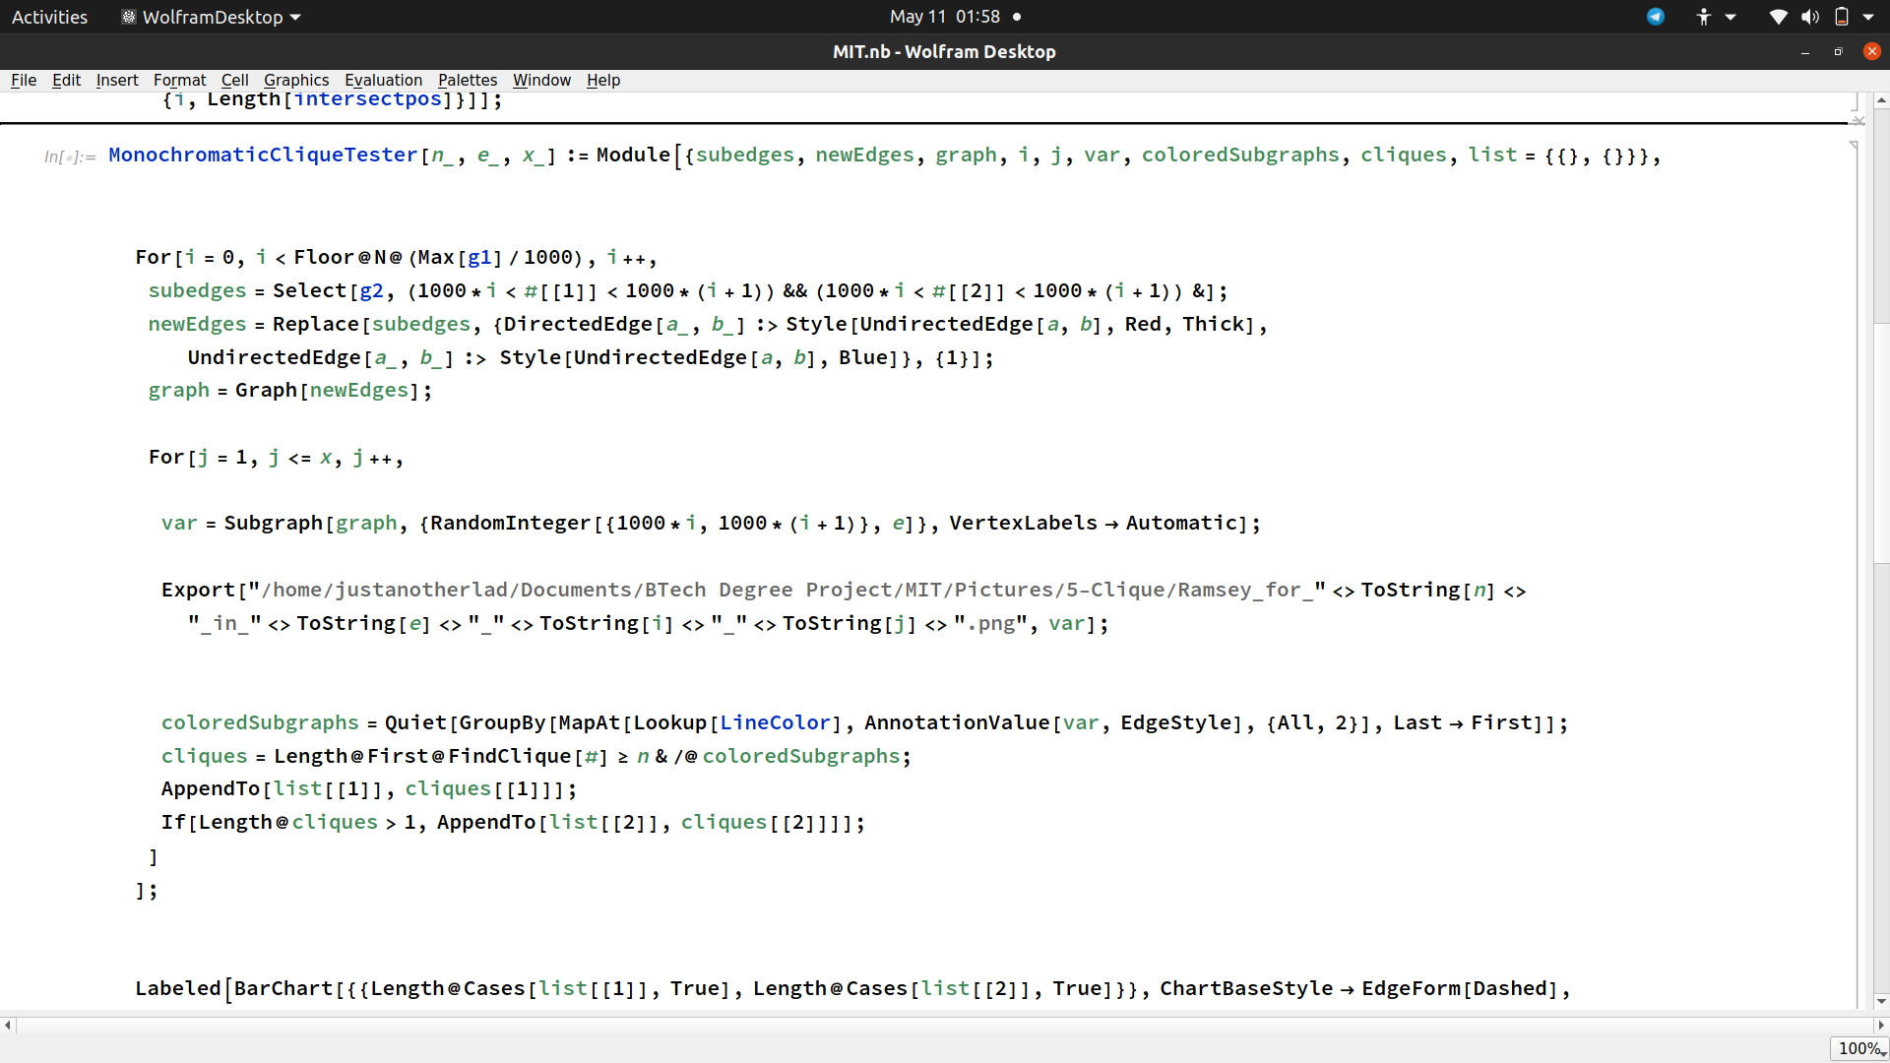

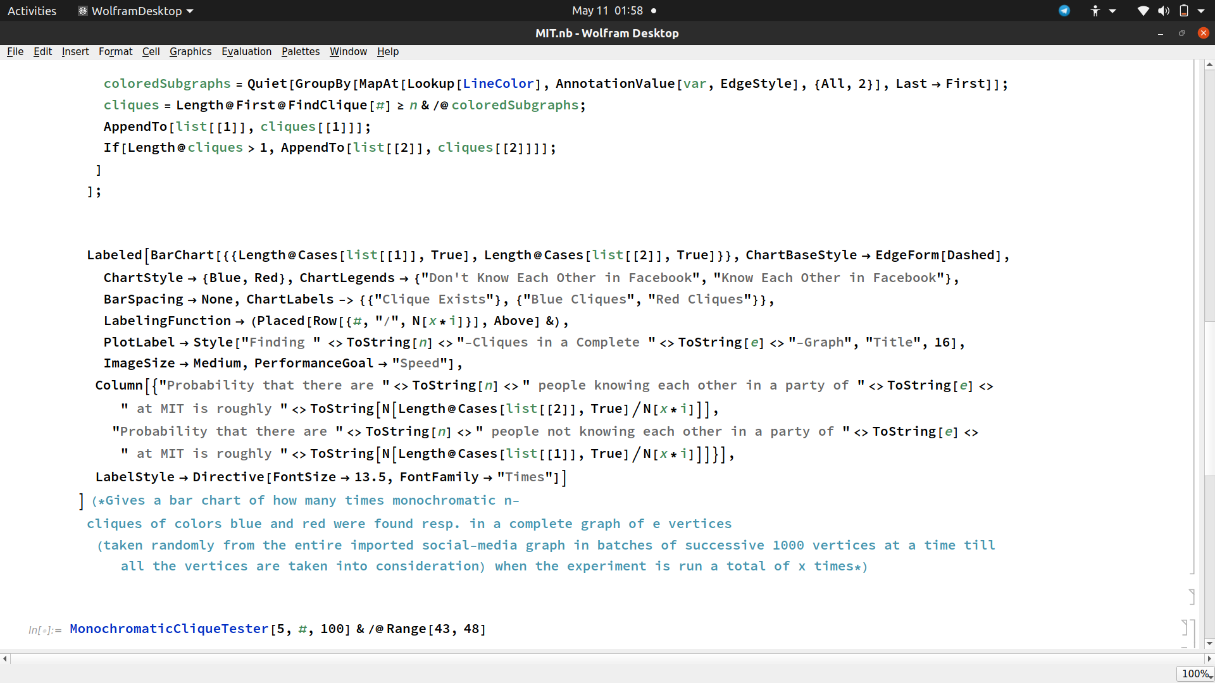

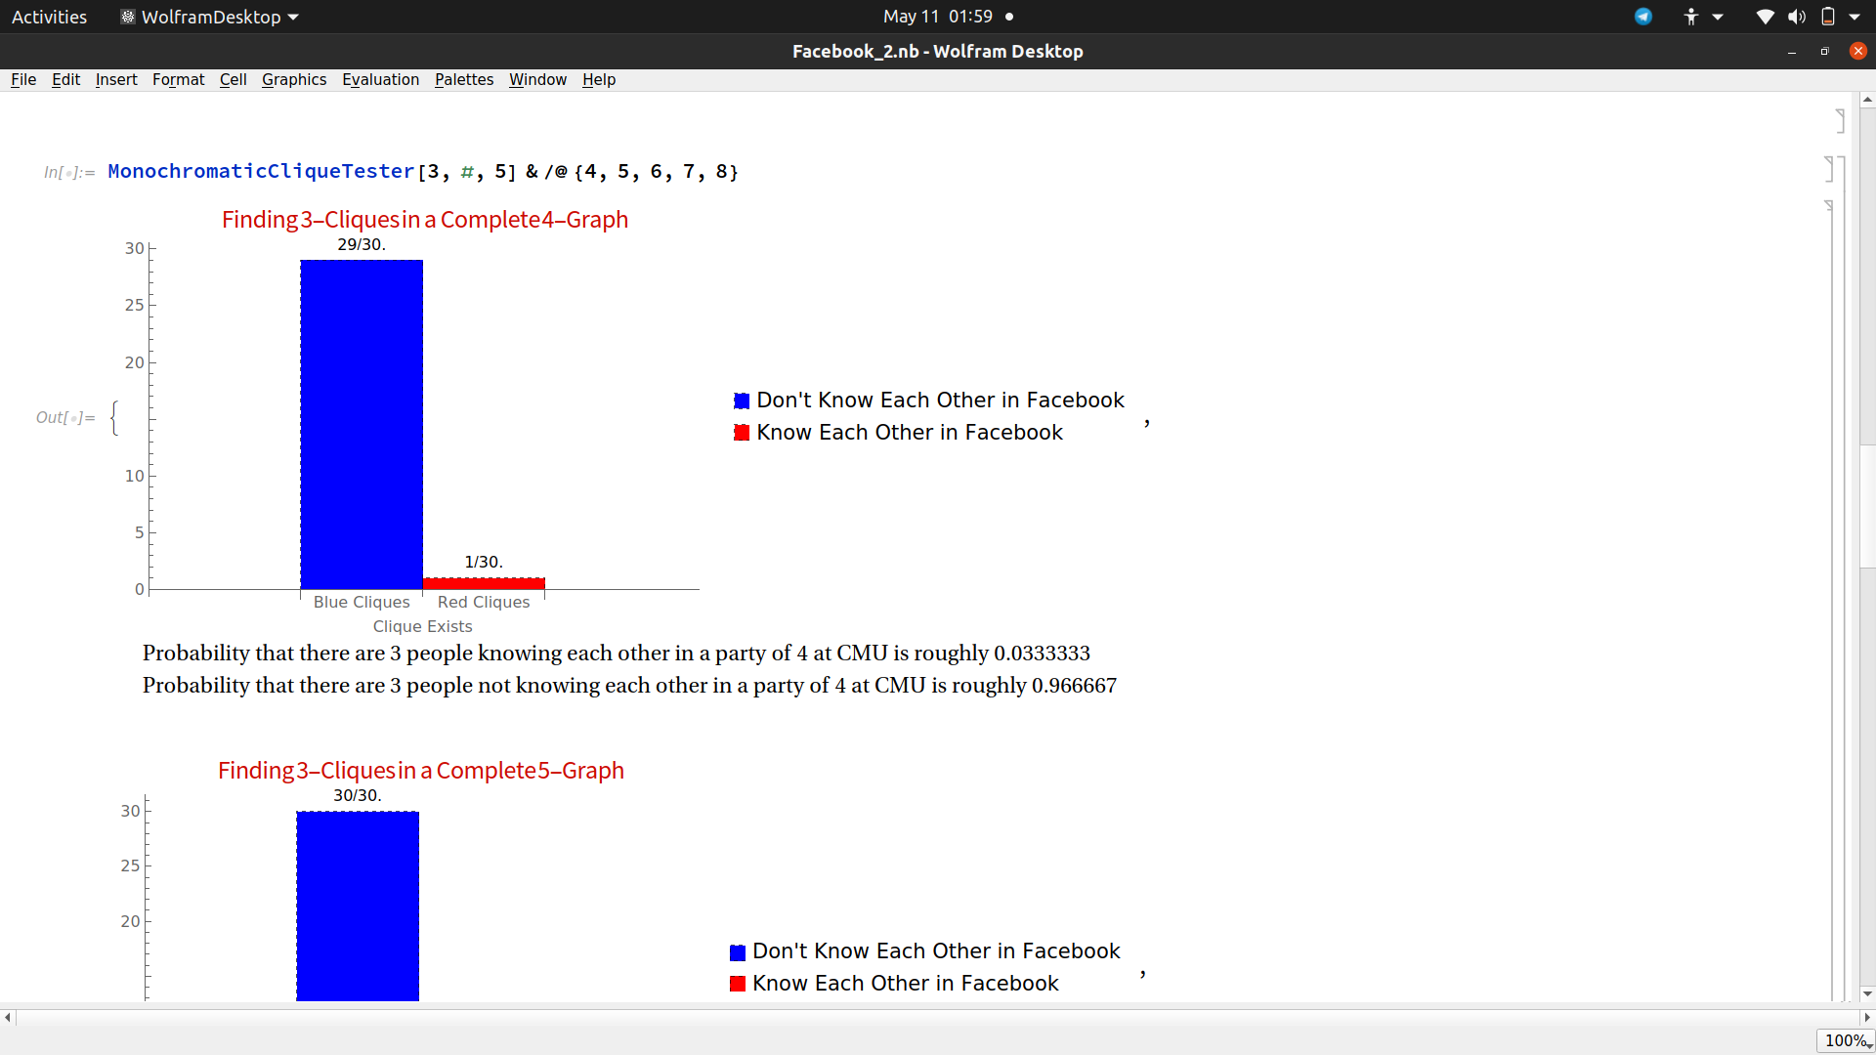

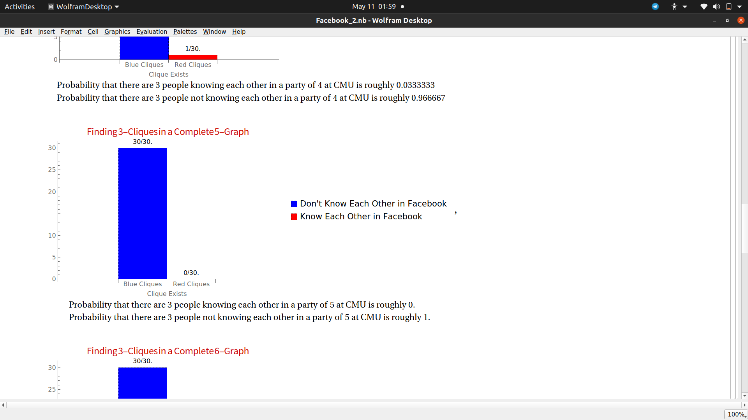

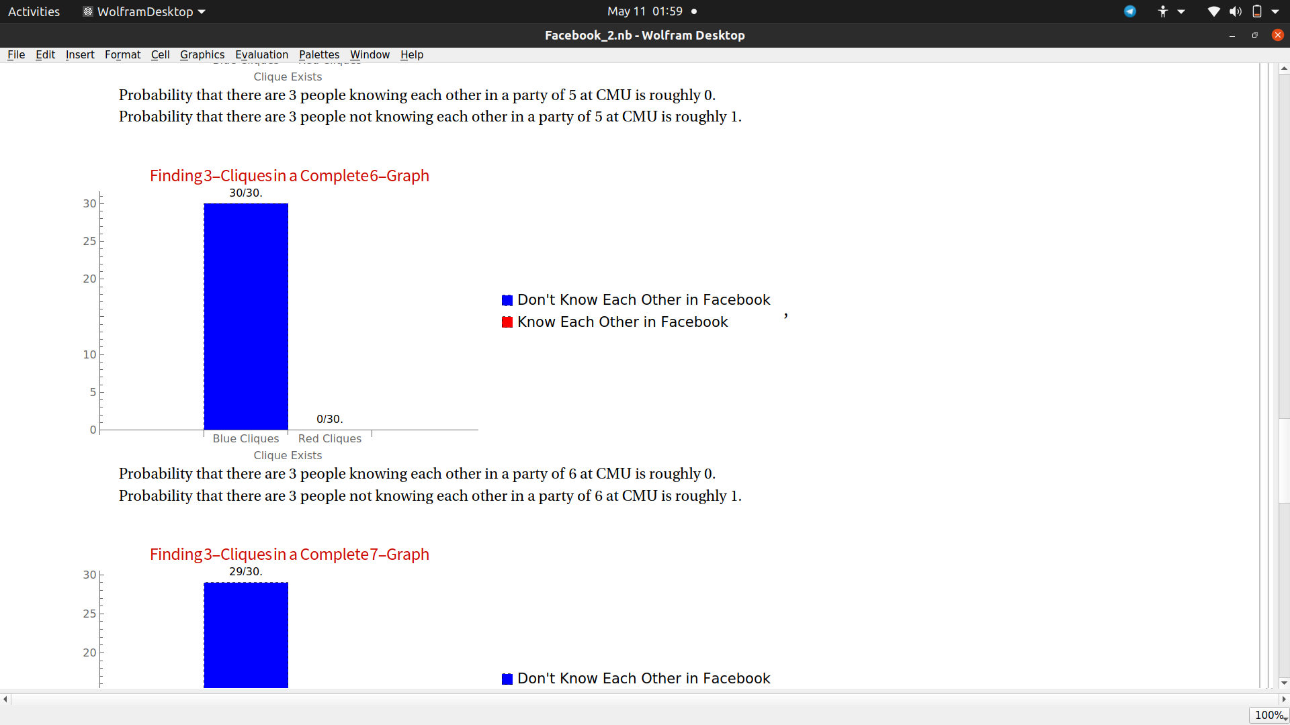

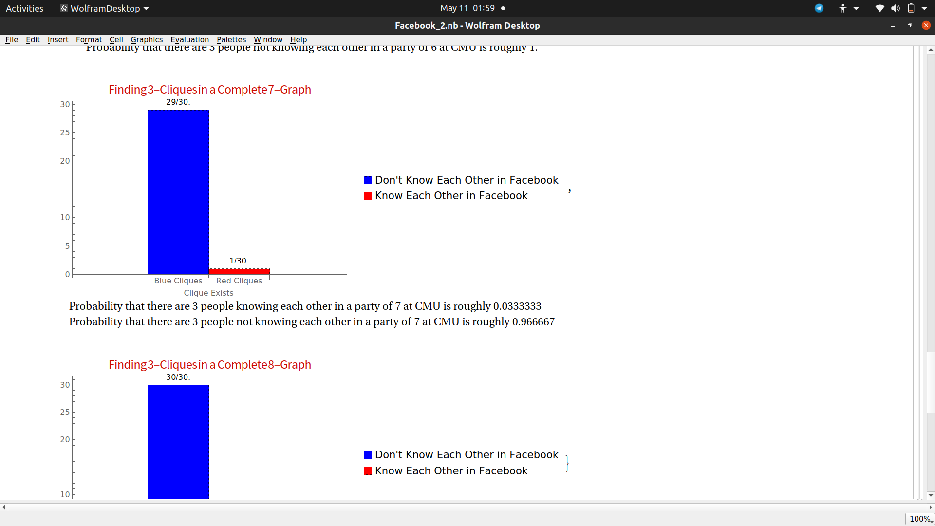

**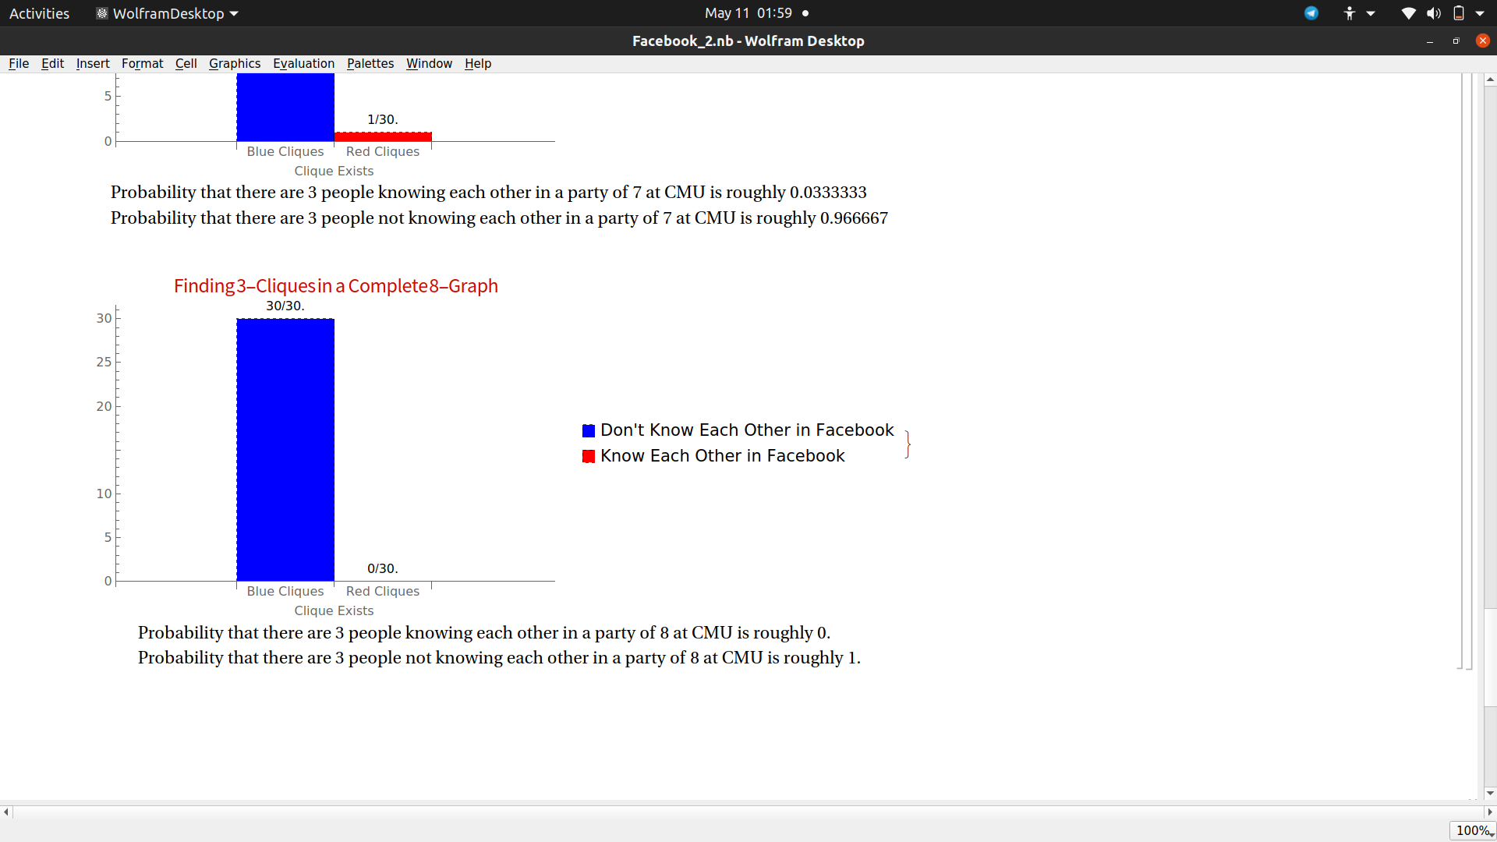**

**PUBLICATION REPORT STATUS**

Submitted, waiting for approval

**PLAGIARISM REPORT**

|  |  |  |  |  |  |
| --- | --- | --- | --- | --- | --- |
| **SRM INSTITUTE OF SCIENCE AND TECHNOLOGY**  (Deemed to be University u/s 3 of UGC Act, 1956) | | | | | |
| **Office of Controller of Examinations** | | | | | |
| REPORT FOR PLAGIARISM CHECK ON THE DISSERTATION **/** PROJECT REPORTS FOR UG**/** PG PROGRAMMES | | | | | |
| 1 | Name of the candidate (**IN BLOCK LETTERS**) | | SWASTIK BANERJEE | | |
| 2 | Address of the candidate | | 42/38 East End Park, Lalkuthi, Kol-39 | | |
| 3 | Registration number | | RA1711008010239 | | |
| 4 | Date of Birth | | 26/06/1998 | | |
| 5 | Department | | Information Technology | | |
| 6 | Faculty | | Engineering and Technology | | |
| 7 | Title of the Dissertation **/** Project | | A Study on Ramsey Numbers using Social Network Analytics | | |
| 8 | Whether the above dissertation is done by | | Individual | | |
| 9 | Name and address of the Supervisor**/** Guide | | **Name:** Dr. D. Hemavathi  **Email ID:** hemavatd@srmist.edu.in  **Phone:** 044-274173000 | | |
| 10 | Name and address of the C0-Supervisor**/** Co-guide (if any) | | NA | | |
| 11 | Software used | | Turnitin | | |
| 12 | Date of Verification | | 16.05.2021 | | |
| 13 | **Plagiarism Details:** (to attach the final report from the software) | | | | |
| **Chapter** | **Title of the Chapter** | **Percentage of similarity index**  **(including self citations)** | | **Percentage of similarity index**  **(excluding self citations)** | **Percentage of plagiarism excluding Quotes, Bibliography, etc** |
| 1. | INTRODUCTION | 3% | | 0% | 0% |
| 2. | LITERATURE SURVEY | 0% | | 0% | 0% |
| 3. | SYSTEM ANALYSIS | <1% | | <1% | <1% |
| 4. | SYSTEM DESIGN & ARCHITECTURE | 0% | | 0% | 0% |
| 5. | SYSTEM TESTING | <1% | | <1% | <1% |
| 6. | RESULT AND ANALYSIS | 1% | | 1% | 1% |
| 7. | CONCLUSION AND FUTURE SCOPE | <1% | | <1% | <1% |
| **Appendices** | | 0% | | 0% | 0% |
| We declare that the above information has been verified and found true to the best of our knowledge. | | | | | |

|  |  |
| --- | --- |
| Signature of the Candidate | Name and Signature of the Staff who uses the plagiarism software |
| Name and Signature of Guide : | Name and Signature of Co - Guide : |
| Name and signature of the Head of Department | |

**